STAKEHOLDER CONSULTATION REPORT

PUBLICATION DATE 05.05.2022
VERSION v. 2.0
RELATED SUPPORT

TEMPLATE GUIDE Stakeholder Consultation Report v.2.0

This is a report template to be used for filling the information pertaining to Local Stakeholder Consultation and Stakeholder Feedback Round conducted in line with the Stakeholder Consultation and Engagement Requirements.

This document contains the following Sections
Key Project Information
Grouped Consultation Information
SECTION A - Information made available to Stakeholders
SECTION B - Invitations made to Stakeholders
SECTION C - Report of the Consultation Process
SECTION D - Continuous input / Grievance mechanism
SECTION E - Stakeholder Feedback Round

This template has been revised to aid a consistent interpretation and to better support project developers submitting documentation for certification. Please read the accompanying guide to understand how to complete this template accurately.- TEMPLATE GUIDE Stakeholder Consultation Report v. 1.2
Please delete blue text boxes upon completion

KEY PROJECT INFORMATION
GS ID of Project | GS-12882
Title of Project | Sidama Improved cook stove distribution project
Version number of this Report | V.2.0
Completion date of version | NA
Time of First Submission Date | 06/06/2023
Start Date of the Project | 01/06/2024
Date of Meeting (s) | 23/05/2023
Project Cycle: | ☒ Regular  ☐ Retroactive

grouped consultation INFORMATION
NA

      - INFORMATION MADE AVAILABLE TO STAKEHOLDERS
        - Preliminary agenda for the meeting
>>
The main agenda of the stakeholder consultation meeting was to discuss with them and to collect information for designing and implementation of improved cook stove distribution project in the target community. The meeting was held in Hawassa town, 23 May 2023 at Rori international hotel, and the detailed agenda of the meeting was:
- Opening of the Meeting
- Explanation of the Project objective, technologies, scale, duration, implementation means and plan, and Gold Standard registration processes
- Presentation of the social, economic and environmental impacts of the project as per the safeguarding principles and requirements, along with potential known positive and negative impacts
- Explanation of the contribution of the project for sustainable development goals (SDGs)
- Discussion on the monitoring plan and data collection tools
- Discussion on providing input/ feedback for the feedback round and methods
- Stove demonstration during health break
- Question and answering/ Clarifications about the project
- Potential Positive impacts
- Discussion of monitoring plan
- Continuous input/grievance handling
- Open sessions for questions and comments
- Evaluation of the meeting and Closing remarks
- Distribution of Evaluation questioners and collection of feedback
- Explain Grievance mechanism, contact details and means
- Closing the meeting

        - A non–technical summary of the project
Sidama region is one of the major coffee producing regions in Ethiopia where local communities are dependent on traditional cooking with biomass fuel and open fire. The forest cover is degrading at an alarming rate by human pressure leading to rapid deforestation, low productivity (coffee Arabica needs tree shade for growth and productivity) and high indoor air pollution that causes serious health impact.
To alleviate this problem, Sidama union in collaboration with Horn of Africa Regional Environment Center and Network (HoA-REC&N) and Fairtrade Africa has initiated carbon finance project to disseminate locally produced multipurpose improved cook stove, Multipurpose cooking stoves in Sidama region, in three selected districts for coffee producer households.

The stoves have 54% fuel reduction from the traditional stoves and will improve productivity by reducing deforestation, reduce indoor air pollution and improve the health condition of user households, reducing GHG emission and generating carbon finance.
The project will be a five year project with two round renewal. It is supported through carbon finance developed with Gold Standard (GS) certification, the highest quality premium for social benefits. To fulfill the requirements of the standard, the first round Local Stakeholders Consultation (LSC) will be conducted from 23 May, 2023 at Hawassa town, Rori international hotel starting from 9:00 am to 1:30pm.
We are kindly requesting you to participate on the LSC Workshop. For those who are not able to attend the physical meeting, please send your input through the following e-mail or phone to:
Mr. Ermiyas Desta, Sidama union. mobile: +251 0913016327 or via email: erm20430@gmail.com during working hours.

Stoves displayed for selection
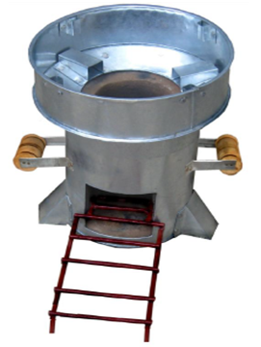 | 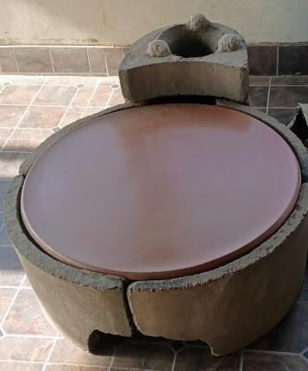 | 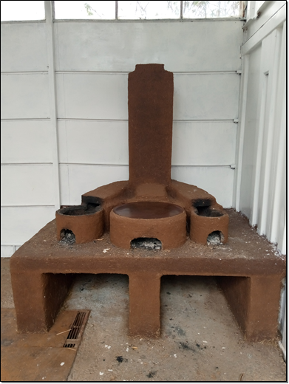
Tikikil stove | Mirt stove | Multi purpose stove

        - Contact details to get further technical detail and project information
>>
For more project information, or further technical detail, please contact:
Mr. Ermiyas Desta,
Sidama union.
Mobile: +251 0913016327
email: erm20430@gmail.com
        - Summary of economic, social and environmental impacts of the Project
>>
The economic, social, and environmental impacts of the project/CPA are summarized as follows:
Social impact:
- Promote social well-being: The project will reduce the physical and health burden on girls and women due to fuel collection; this increases learning opportunities for girls and opportunities for productive and social application of time and effort for women. Reduction of burning of fuel woods in target households will cut indoor air pollutants dramatically. This will reduce child mortality and improve maternal health. The action will also improve living household sanitation.
Economic impact:
- The production, dissemination and maintenance of the improved technology will create job opportunity for the producers and generate incomes for women and youth groups in the target area. As well as, the use of technologies will reduced the time spent for collection of fuel wood in rural communities and save money for urban residents who buy the fuel. The carbon finance will also generate additional income for technology users.
Environmental impact:
- The project reduces deforestation and GHG emission from the use of nonrenewable biomass by replacing traditional stoves using fuel saving technologies in the target community. The technology reduce the amount of fuel wood consumed by half and emission by 70% for cooking.

Other relevant information to help stakeholders understand the project
>>

      - INVITATIONS MADE TO STAKEHOLDERS
        - Invitation tracking table
Please complete the table below

Category Code | Stakeholder Type/Organisation (if relevant) | Name of invitee |  | Male/  Female |  | Method of invitation |  | Date of invitation  (>30 days before Meeting)
D | Ethiopia EPA | DNA |  |  | F |  | email | Yes
F | Gold Standard representative | help@goldstandard.org |  |  | N/A |  | email | Yes
D | Ministry of Water and Energy | Yisehak Seboka |  |  | M |  | email | yes
E | Oromia Coffee Farmers Cooperative Union | Degne Guta |  |  | M |  | Letter | Yes
A | Sidama Coffee Farmers Cooperative Union | Ashenafi Alito |  |  | M |  | Letter | Yes
C | Bureau of Agriculture | Dawit Botte |  |  | M |  | Letter | Yes
C | ‘’ | Shalu Kintamo |  |  | M |  | Letter | Yes
C | Dalle Woreda |  | Bagnu Bekele |  | M |  | Letter | Yes
C | Water, mine and Energy Office |  | Abera Arfasa |  | M |  | Letter | Yes
D | Water, mine and Energy Office Office head |  | Fikadu Kersima |  | M |  | Letter | Yes
C | Water, Mine and Energy Office |  | Wolden H/Mariam |  | M |  | Letter | Yes
D | Water, mine and Energy Office Office head |  | Zeritu W/senbet |  | F |  | Letter | Yes
A | Primary Cooperative |  | Tesfaye Yihanis |  | M |  | Letter | Yes
A | Primary Cooperative |  | Tigist Zeleke |  | F |  | Letter | Yes
A | >> |  | Legges Alnbo |  | F |  | Letter | Yes
A | >> |  | Mengesha Antamo |  | M |  | Letter | Yes
A | >> |  | Melesse Shewa |  | M |  | Letter | Yes
A | >> |  | Elfinesh Ettisso |  | F |  | Letter | Yes
A | >> |  | Zegge Amigo |  | F |  | Letter | Yes
A | >> |  | Demise Kita |  | M |  | Letter | Yes
A | >> |  | Alemitu Bialrda |  | F |  | Letter | Yes
A | >> |  | Tikile Bogale |  | F |  | Letter | Yes
A | >> |  | Bizuneh Hatiso |  | M |  | Letter | Yes
E | HoAREC/N |  | Negusu Tefera |  | M |  | Letter | Yes
E | >> |  | Ayantu Girma |  | F |  | Letter | Yes
C | Woreda Administration |  | Mengesha Fitamo |  | M |  | Letter | Yes
C | Woreda M/E/O/ head |  | Abebayehu Kasaye |  | M |  | Letter | Yes
A | Primary cooperative |  | Asregid Asefa |  | M |  | Letter | Yes
A | >> |  | Sara Kora |  | F |  | Letter | Yes
A | >> |  | Hani Shudura |  | F |  | Letter | Yes
C | Region EFCC |  | Babiso Batiso |  | M |  | Letter | Yes
A | Primary Cooperative |  | Gebyanesh Gadada |  | F |  | Letter | Yes
A | >> |  | Dinkinesh Eshetu |  | F |  | Letter | Yes
A | >> |  | Etabech Hoyam |  | F |  | Letter | Yes
A | >> |  | Haftu Herteba |  | F |  | Letter | Yes
A | >> |  | Hibret Gesese |  | M |  | Letter | Yes
A | >> |  | Abinet Konta |  | M |  | Letter | Yes
A | >> |  | Hassni Bogale |  | F |  | Letter | Yes
A | >> |  | Degife Guribayo |  | M |  | Letter | Yes
A | >> |  | Gesese Gutite |  | M |  | Letter | Yes
A | >> |  | Abederamani Gamiso |  | M |  | Letter | Yes
A | >> |  | Firewu Erofwani |  | F |  | Letter | Yes
A | >> |  | Niguse Gumura |  | M |  | Letter | Yes
A | >> |  | Kasech Biftu |  | F |  | Letter | Yes
A | >> |  | Meselech Yutala |  | F |  | Letter | Yes
A | >> |  | Amarech Bue |  | F |  | Letter | Yes
C | Woreda Women and Youth Office |  | Wudinesh Kassa |  | F |  | Letter | Yes
B | Farmers |  | Nuru Fakiso |  | M |  | Letter | Yes
B | >> |  | Biadigelign Belam |  | M |  | Letter | Yes
B | >> |  | Feyisa Fesardi |  | M |  | Letter | Yes
B | >> |  | Habteyesus Medigeng |  | M |  | Letter | Yes

          - Appropriateness of methods
>>
Farmers, local and regional officials were invited for the meeting by a formal letter written in both English and local language accompanied with non-technical summary. The national government offices like the environment commission and water and energy ministry were invited by an email attached with the formal invitation letter. Phone reminder and conformation call was made one week prior to the meeting. Open invitation was also posted in the target area to allow /give chance/ interested individuals to attend the meeting and provide their input.
Selections of potential stakeholders were made in consultation with primary Cooperatives and the invitations were sent through them. Invitations were sent before 30 days in advance from the date of the physical meeting in both English and in Amharic (local language) as deemed appropriate. Stakeholders who are unable to participate in the physical meeting were encouraged to provide their comments via email or telephone.
          - Gender Sensitivity
>>
The stakeholder consultation process was designed and implemented in line with Gold Standard requirements, mainly Stakeholder Consultation and Engagement Requirement (Version 2,1), Stakeholder Consultation and Engagement Guidelines (Version 2.0), and Gender Equality Requirements & Guidelines (version 2.0), which ensured that the design is in compliance with the Gender Safeguarding Principles and Requirements, and is gender sensitive. The women representatives from the Coffee farmers Union, Primary cooperatives, Women & Children Affairs and Zone and Woreda Administration office were invited. Out of 50 participants of the meeting, approximately 42% were women (21 women).
          - Evidence proving invites took place as stated
>>
Sample invitation letter, screen shots of emails, and Non-technical project summary are presented below.
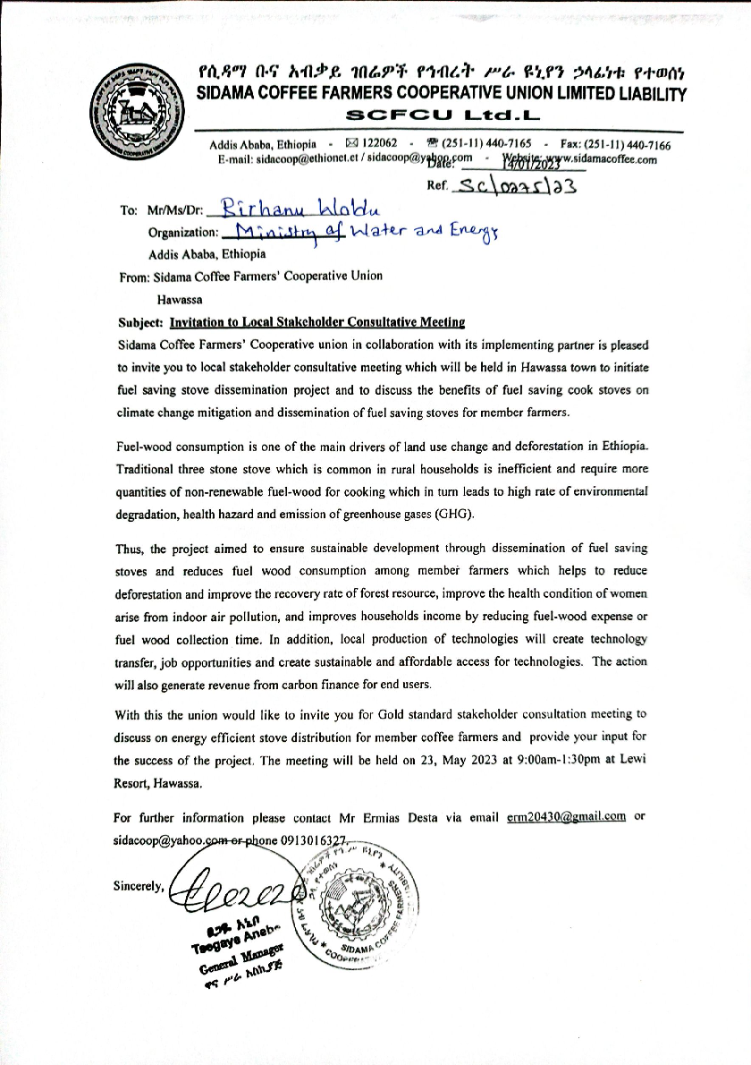
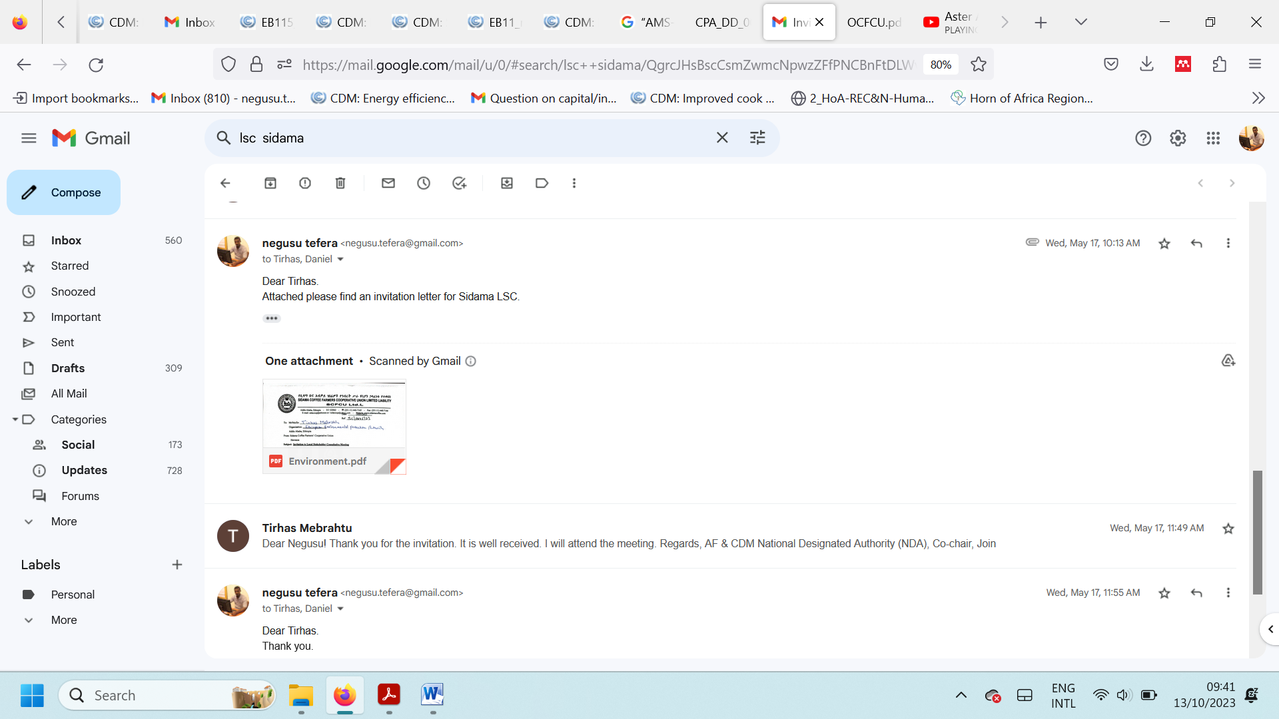

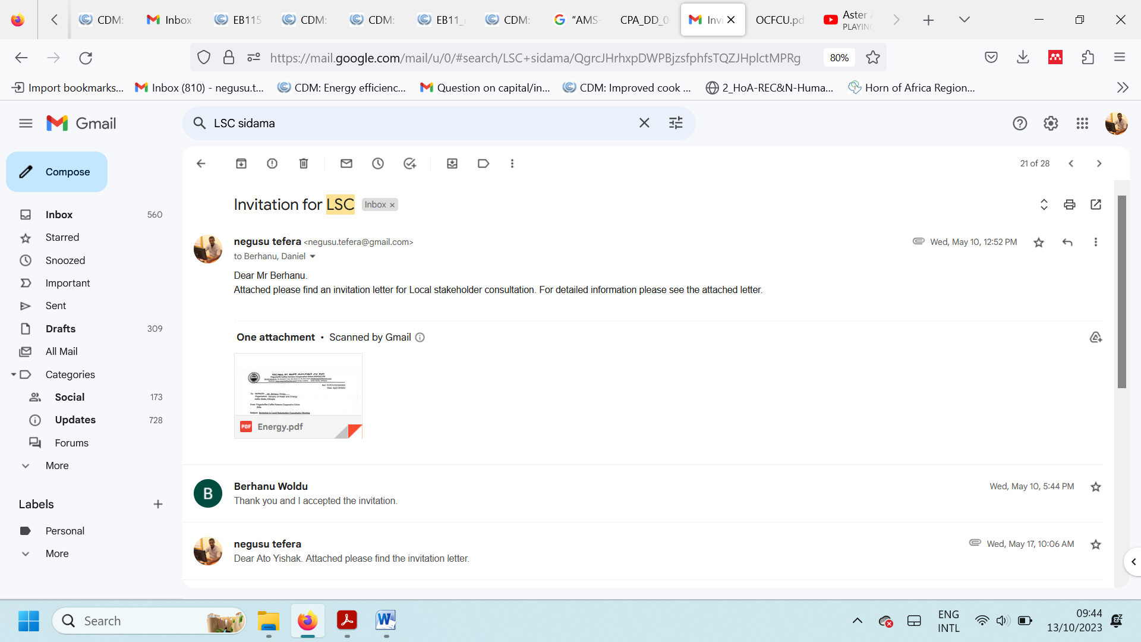

          - Sample content of invites (for each Method above)
>> The following key points were included in the letter invitations and the email:
- project description
- Purpose of the meeting
- Social, environmental and economic importance of the project
- Meeting date, venue, and time
- Contact details of the responsible individual whom the stakeholders can contact for additional information or provide comments.
Please refer to Section B.1.3 for the screenshots of letters, emails and Non-technical project summary that were a part of each email or letter sent to the stakeholders.
          - Description of other Means and methods to provide feedback for those who are not able to join the consultation meeting
>>
Contact details of the responsible individual (i.e. phone number and email address) were written on both non- technical summary and invitation letters. Those who were not able to attend the physical meeting were encouraged to provide their feedback physically, through emails, telephone or any communication means convenient for them.

      - REPORT OF THE CONSULTATION PROCESS
        - Date of Meeting
>>
The physical meeting was held on 23 May2023

          - Justification of why consultation took place after the project start date (retroactive projects only)
>> N/A
          - List of participants

Date and Time | 23/05/2023  9:00am-1:30pm | Location | Hawassa town

Category  Code | Name of the participant, job /  position in the community | Male /  Female | Contact details | Organisation  (if relevant) | Signature
D | Tihras Mebrahtu | F | 0912464234 | Ethiopia EPA (DNA)
D | Yisehak Seboka | M | 0911955889 | Ministry of Water and Energy
E | Degne Guta | M | 0911130275 | Oromia Coffee Farmers Cooperative Union
E | Ashenafi Alito | M | 0916126423 | Sidama Coffee Farmers Cooperative Union (SCFCU)
C | Dawit Botte | M | 0946830414 | Bureau of Agriculture
C | Shalu Kintamo | M | 0916505186 | ‘’
C | Bagnu Bekele | M | 0916029358 | Dalle Woreda
C | Abera Arfasa | M | 0916031003 | Water, mine and Energy Office
C | Fikadu Kersima | M | 0923366068 | Office head
C | Wolden H/Mariam | M | 0916446777 | Water, Mine and Energy Office
C | Zeritu W/senbet | F | 0916328425 | Office head
A | Tesfaye Yihanis | M | 0916379084 | Primary Cooperative
A | Tigist Zeleke | F | 0916130536 | Primary Cooperative
A | Legges Alnbo | F | 0916130830 | >>
A | Mengesha Antamo | M | 0916155293 | >>
A | Melesse Shewa | M | 0910534279 | >>
A | Elfinesh Ettisso | F | 0945837052 | >>
A | Zegge Amigo | F | 0916140620 | >>
A | Demise Kita | M | 0916141277 | >>
A | Alemitu Bialrda | F | 0940052801 | >>
A | Tikile Bogale | F | 0916813405 | >>
A | Bizuneh Hatiso | M | 0919737001 | >>
E | Negusu Tefera | M | 0911775595 | HoAREC/N
 | Ayantu Girma | F | 0912114830 | >>
C | Mengesha Fitamo | M |  | Woreda Administration
C | Abebayehu Kasaye | M | 0916851231 | Woreda M/E/O/ head
A | Asregid Asefa | M | 0913497125 | Primary cooperative
A | Sara Kora | F | 0916924968 | >>
A | Hani Shudura | F | 0928799787 | >>
C | Babiso Batiso | M | 0979935574 | Region EFCC
A | Gebyanesh Gadada | F | 0916923261 | Primary Cooperative
A | Dinkinesh Eshetu | F | 0934773052 | >>
A | Etabech Hoyam | F | 0909741290 | >>
A | Haftu Herteba | F | 0916044321 | >>
A | Hibret Gesese | M | 0924882020 | >>
A | Abinet Konta | M | 0926988643 | >>
A | Hassni Bogale | F | 0924655356 | >>
A | Degife Guribayo | M | 0934735492 | >>
A | Gesese Gutite | M | 0912092595 | >>
A | Abederamani Gamiso | M | 0900115832 | >>
A | Firewu Erofwani | F | 0911335750 | >>
A | Niguse Gumura | M | 0911384507 | >>
A | Kasech Biftu | F |  | >>
A | Meselech Yutala | F | 0926389092 | >>
A | Amarech Bue | F | 0978709968 | >>
C | Wudinesh Kassa | F | 0916851470 | Woreda Women and Youth Office
B | Nuru Fakiso | M | 0916503519 | Farmers
B | Biadigelign Belam | M | 0921790631 | Farmers
B | Feyisa Fesardi | M | 0916166913 | Farmers
B | Habteyesus Medigeng | M | 0916330811 | Farmers

          - Pictures from the physical meeting(s) (best practice)
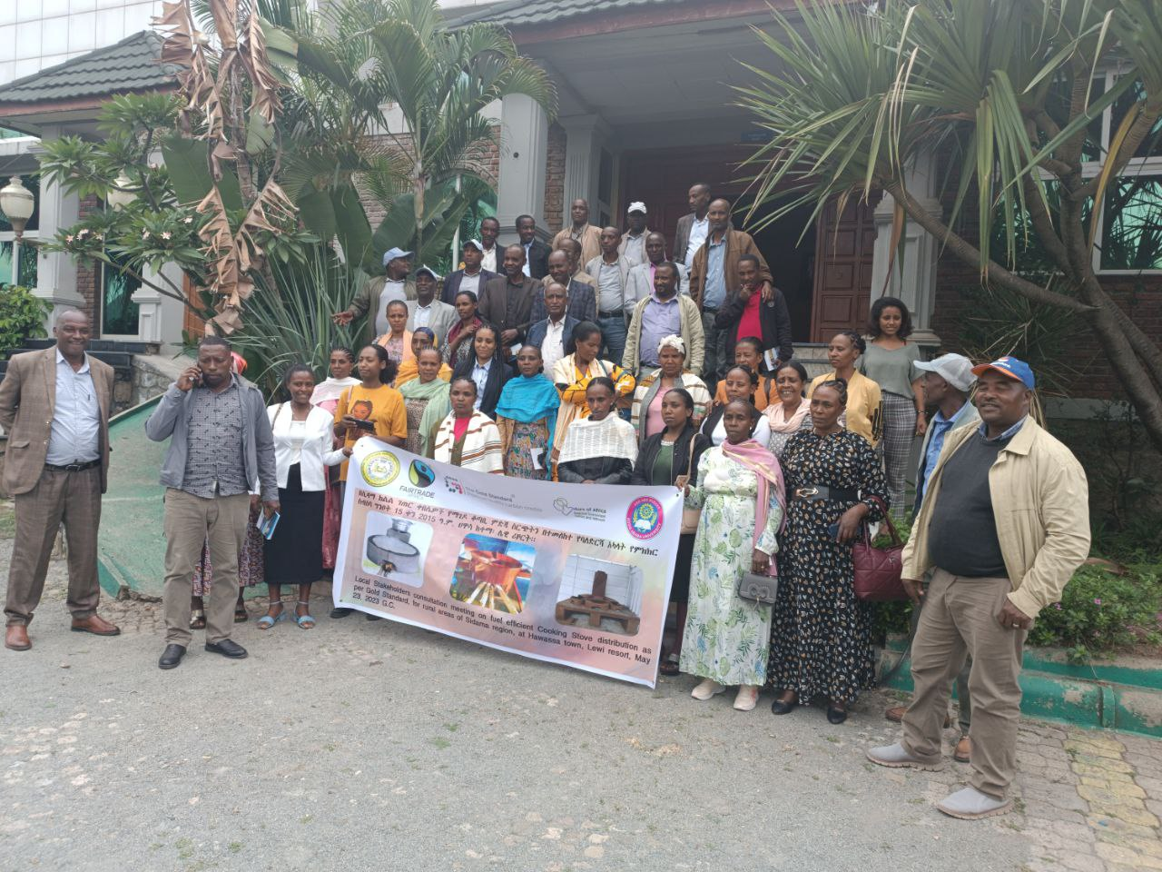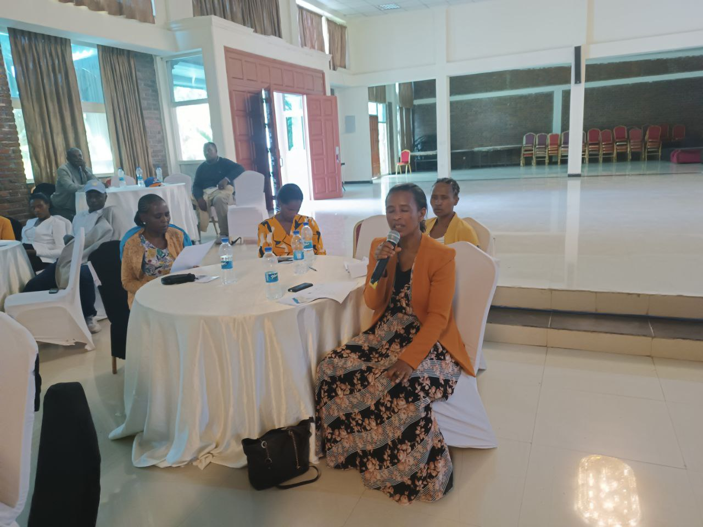
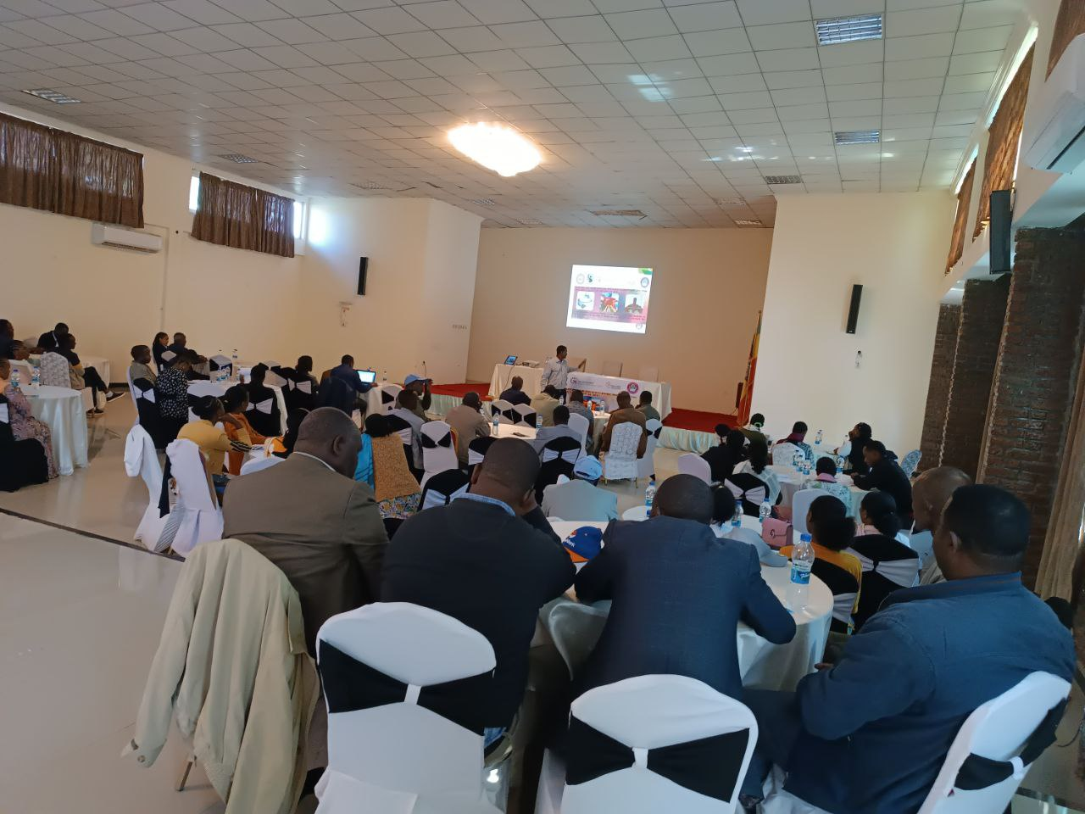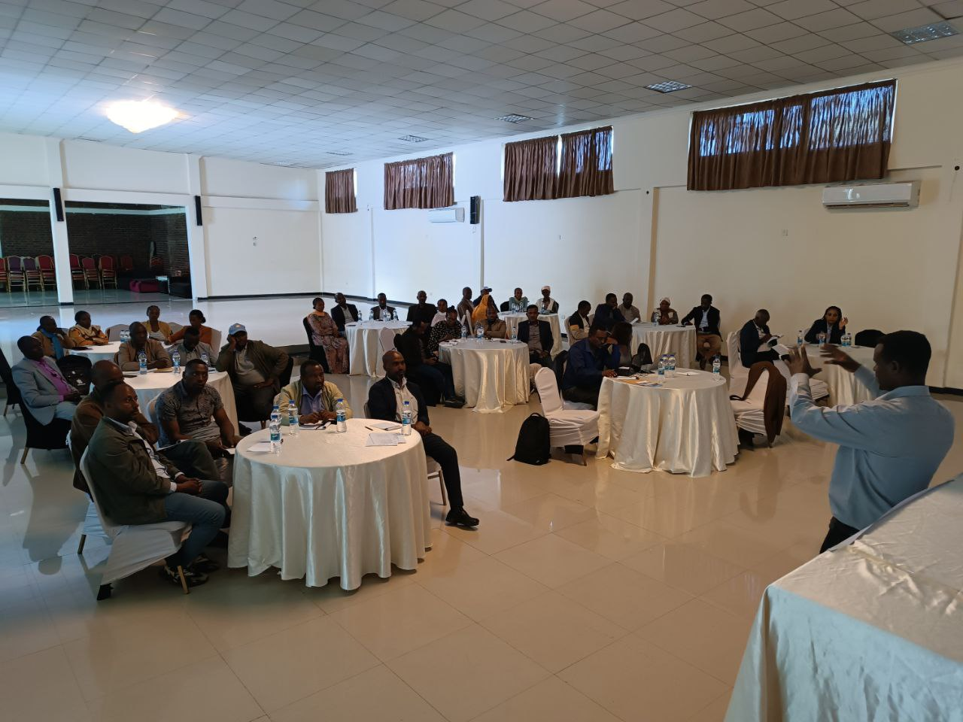
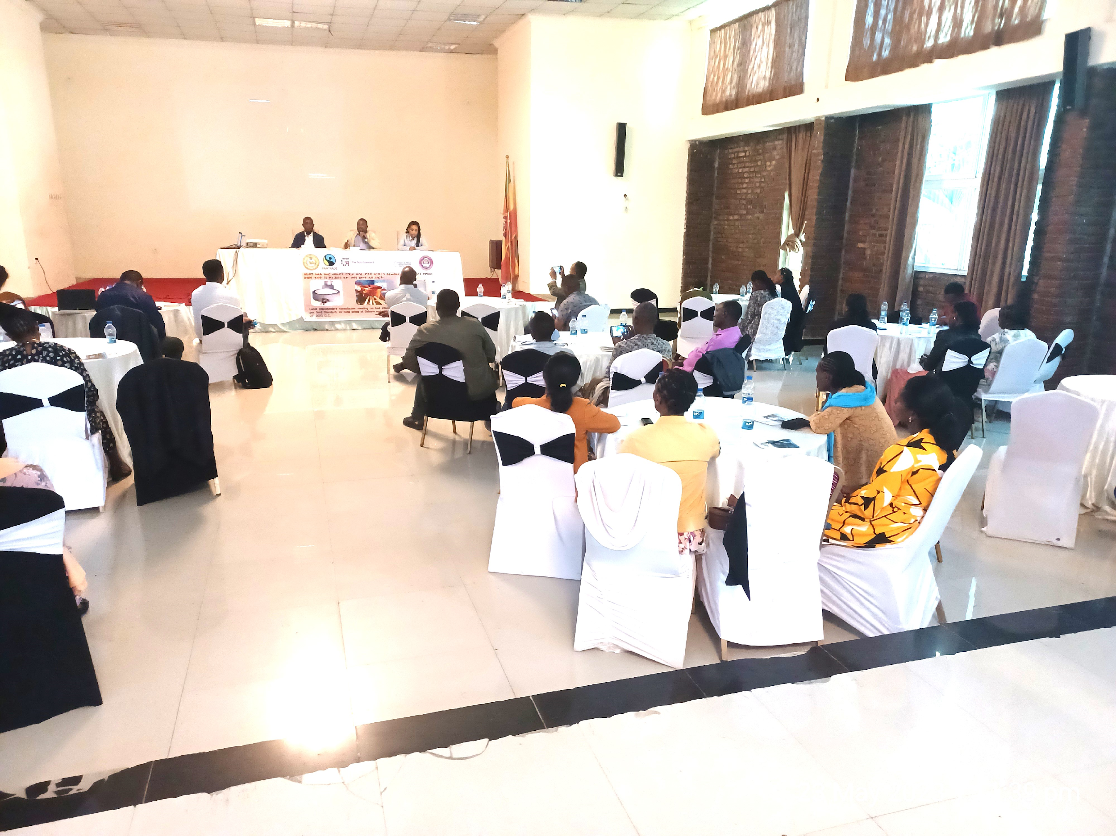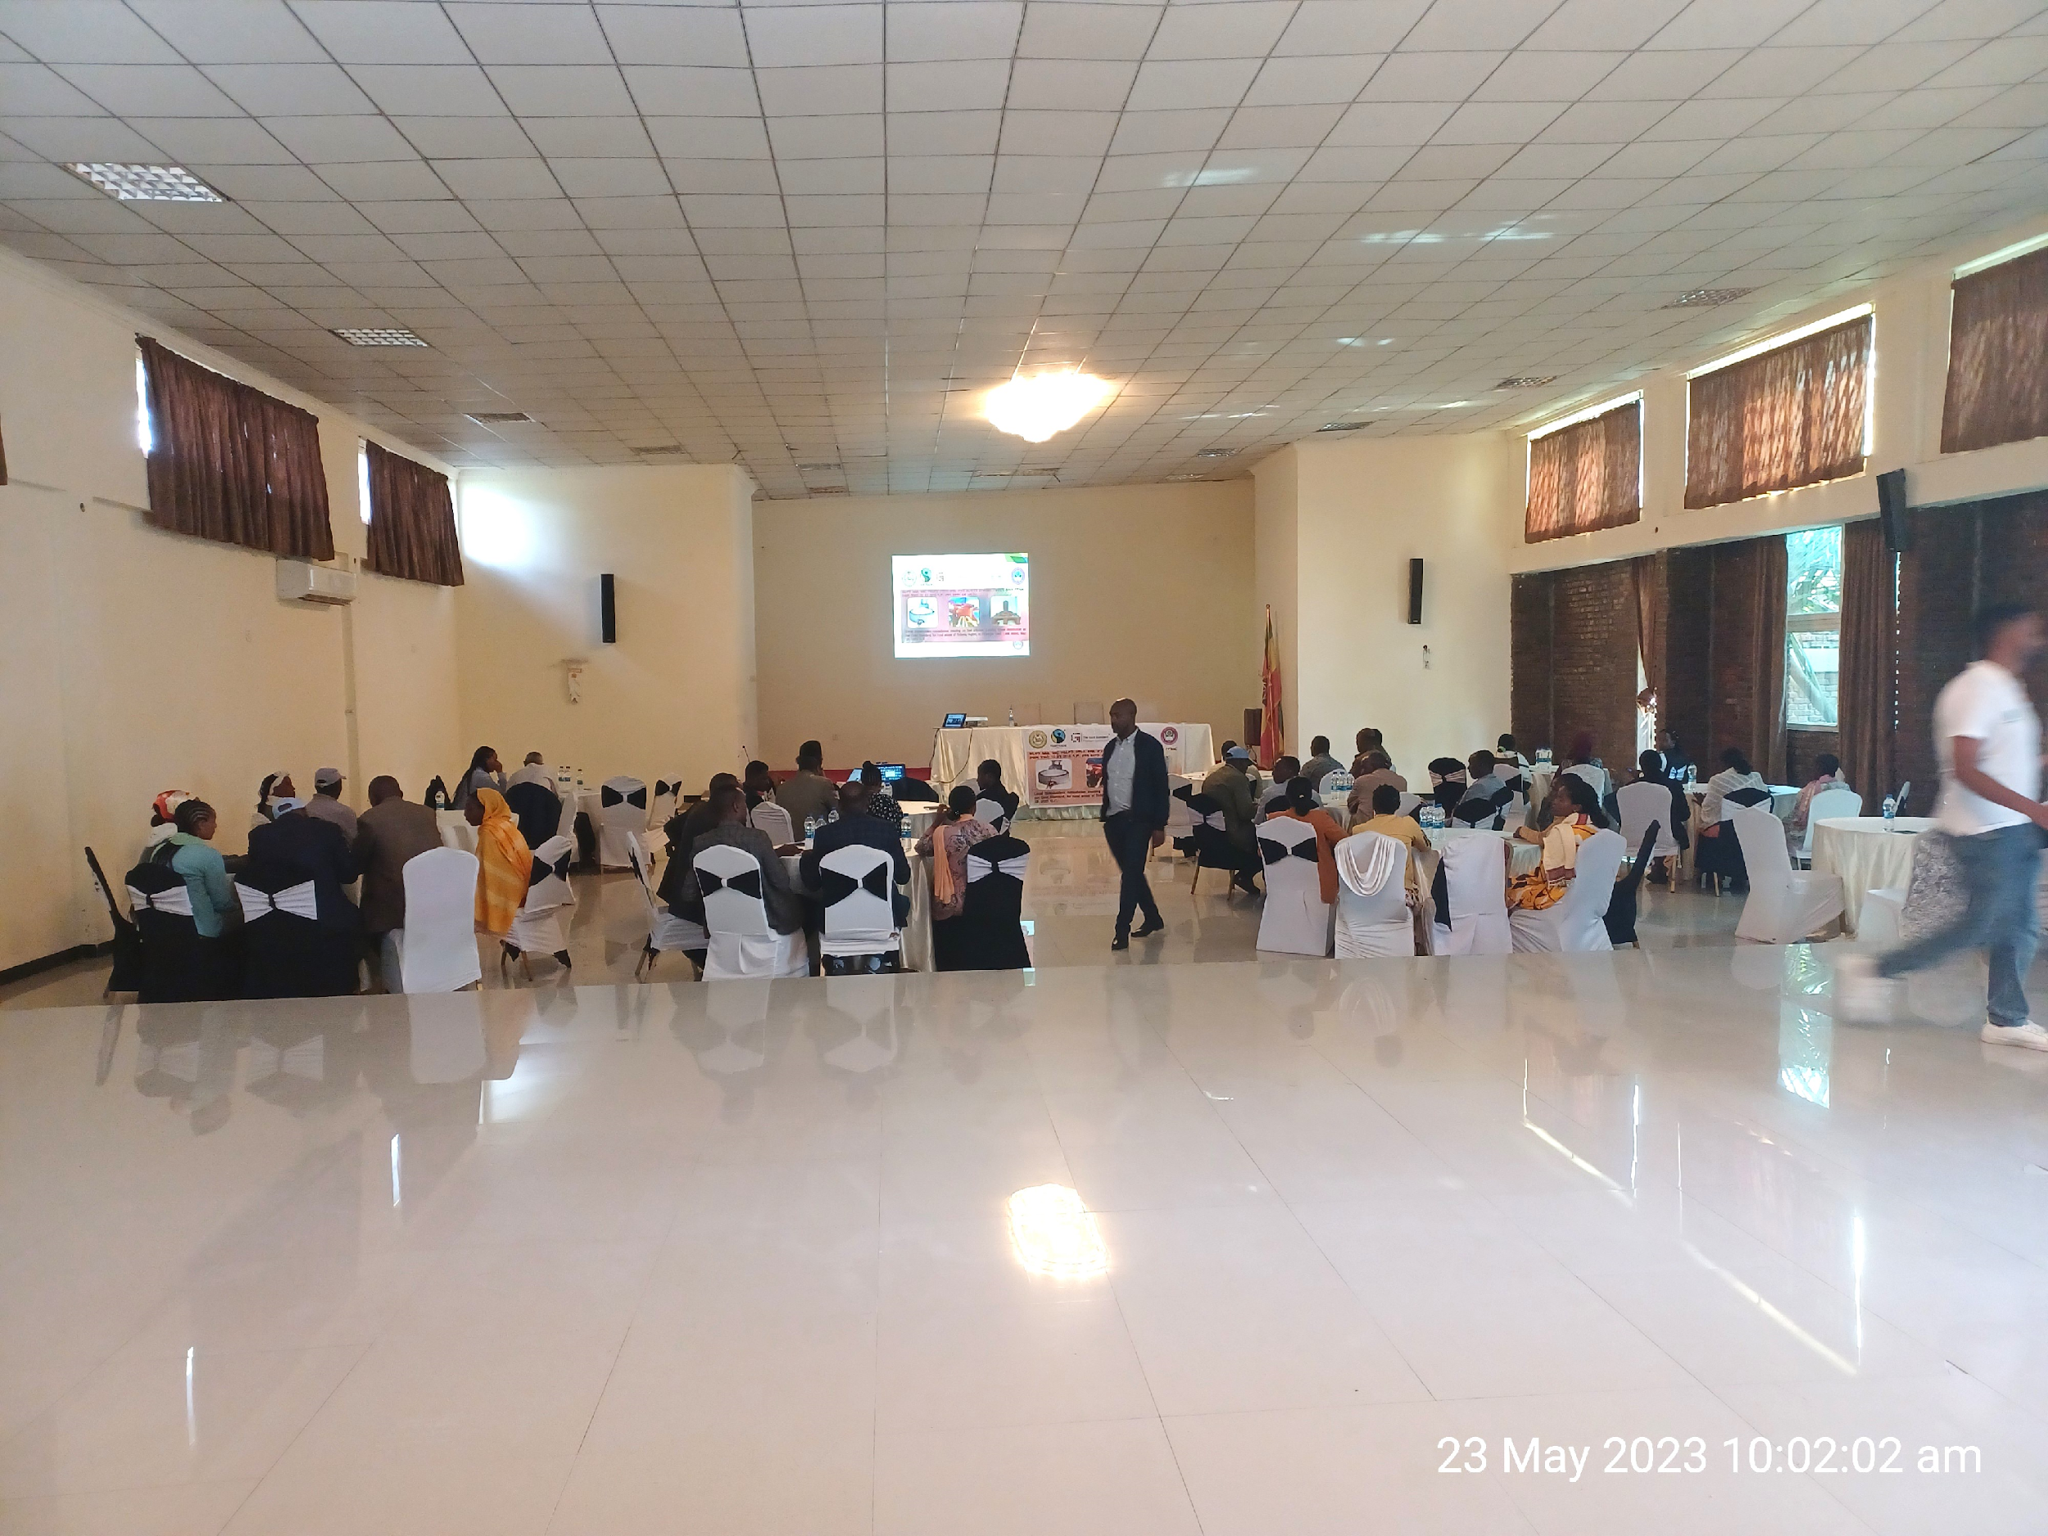
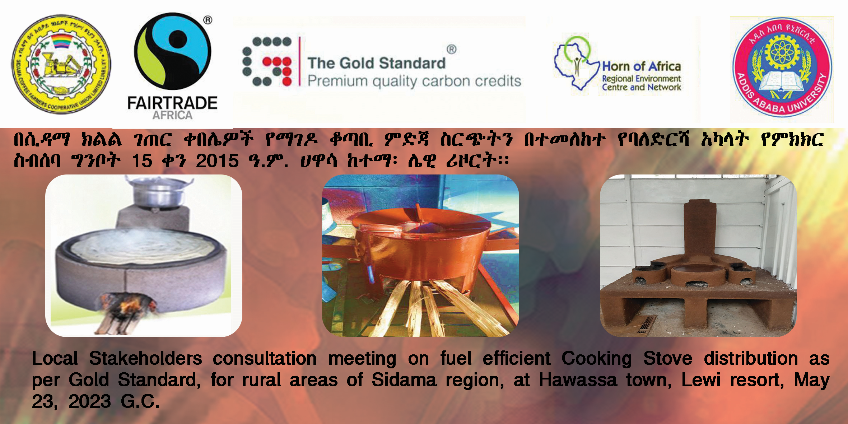
        - Minutes of physical meeting(s)
>>
Participants of the meeting were arrived on time, registered and the meeting was started at 9:30 am. A total of 50 participants of which 21 women were attend the meeting.
Mr. Negusu Tefera, Sustainable Energy, Carbon and urban resilience programme Coordinator, Horn of Africa regional Environment Centre and Network, introduced the day’s programme and invited the participants for self-introduction. All participants introduce themselves mentioning their name, organization and their position/responsibility. Then opening speech was made.

>> Opening of the meeting
The opening speech was made by Mr. Mengesha Fitamo, Aleta wondo woreda/District administration opened the meeting officially. On his speech, he mentioned the importance of the project, its contribution for forest conservation, community health and climate change mitigation. He mentioned that the project is crucial for their community especially for women and girls who spent most of their time in cooking in a harsh condition. He also appreciated all workshop participants from Cooperatives, District, Zone, region and Federal for coming to attend the consultation workshop.

Explanation of the project
After opening speech, presentation on was given by Mr. Negusu on the Project objective, technologies, scale, duration, implementation means and plan, and Gold Standard registration processes, Presentation of the social, economic and environmental impacts of the project was presented as per the safeguarding principles and requirements, along with potential known positive and negative impacts. Contribution of the project for sustainable development goals (SDGs) was also explained.
He also presented about global climate change by explained the objective of the consultation meeting and clarification for participants on the climate change: causes (releasing of GHGs from Industrialization, fuel wood, waste, expansion of agriculture land, land use change, urban expansion, etc) and its impacts (drought, flooding, soil erosion, high temperature etc) especially in the developing countries with pictures which are easy to understand. He extended his explanation on the climate change and carbon emission trading or climate financing, its processes ( from Initiation to registration, certification and issuance) and benefits by referring the national and international conference agreements, goals and plans/strategies and also experiences from others countries and from Oromia coffee farmers Cooperative Union that already registered under Gold Standard. He also highlighted the COP agreements and international Emission reduction and Carbon credit mechanism at developed and developing countries level and trading mechanisms.
Mr. Negusu extended his articulation that this energy efficient cook stove project is different from the usual projects and it has been following up and monitored by authorized body to ensure the emission reduction and community benefits (carbon revenues and fair-trade certification and premium fee due to carbon neutral coffee production). He explained in detail how the emission reduction particularly CO₂ will be monitored and certified.
Mr. Negusu mentioned that in addition to reduce deforestation and climate change, this project has been positively impacting the life of the communities especially those vulnerable groups of the community (women and children) through reducing in-door air pollution and improving their health and save their time, labor and money. He briefed that the present technologies are tested and certified by Ministry of Water and Energy which has the potential of reduce the fuel wood consumption by more than 53%.
He explained in detail about the project implementation. It will be implemented in three districts namely Aleta wondo, Dale and Dara districts. He highlighted the responsibilities of each stakeholders participating on the LSC from federal to local and He emphasize that the project owner is Sidama union and it has been implemented by their own budget or loan from bank, labor and efforts because of the project will be illegal for carbon trading if it implemented by grant or others public funds.
Mr. Negusu continued his presentation by outlining the advantages of different improved stoves that were on display. The implementation and monitoring plan, how data will be collected and emission reduction will be calculated.
The federal EPA representative Mrs. Tihras and the minister of water and energy Mr. Yisek strengthened the ideas that had already been raised, and Ms. Tihras emphasized that if the project will properly implement by the owner, it would have a positive impact on protecting the environment and community health.
Additionally, Mr. Yisek emphasizes in depth the comparison of fuel-saving stoves to three-stone open stoves, their impacts on society, the environment, and the economy, as well as the costs of the existing Mirti stove up to 800ETB and the multipurpose stove from 1500 up to 2000ETB. He also suggests financing mechanism as loan or credit from finance sectors. He stressed the minister's commitment to supporting the project on the issue of technology before dissemination.
Mr. Degnu from the Oromia Coffee Farmers Cooperative Union shared his experiences with the participants regarding the impacts of climate change, including the impacts of indoor air pollution on health problems. He also explained the advantages of carbon funding.

Questions and answers session about the project
Mr. Ermias from Sidama Coffee farmer’s cooperative union invites participants to raise questions, comments and suggestions.
Mr. Mengesha Fitamo from Aleto Woreda Administration highlighted the national and international efforts being made to reduce the impacts of CO₂ emissions, and they expressed their appreciation for the project's idea in terms of its advantages for health, empowering women and children, increasing productivity, and generating income from carbon finance..., Mr. Mengesha explained their idea in the local language Sidamigna and he has raised a concern how these benefits would be provided for the farmers/for end users and how the financial issue would be resolved.
Mr. Bagnu Bekele( Dale Woreda Administration) mentioned regarding the need for better technology for rural community and asked how to calculate emission reduction. Among the technology options displayed, he preferred the multipurpose stove over the other fuel-saving models because it could be made from local materials and met local cooking habit. Mr. Bagnu concluded by mentioning that, awareness for improved technologies is less among all stakeholders, including woreda experts and recommended that frequent awareness raising training of stakeholders is crucial.
Mr. Melesse Shewa from the primary cooperative described that despite the time shortage, the discussion was productive, especially in raising awareness of the project concept. He stated that the rural community prefers to see the impacts rather than hear about them, so he reaffirmed his commitment to making the cooperative members aware. A question regarding the initial funding to startup the project for technology production and other expenses as well as technical support was raised by Mr. Fikadu from the woreda Administration.
Ms. Zeritu W/senbet from Woreda Administration emphasizes that women are particularly vulnerable because they must collect fuel and prepare food on open three-stone stoves, both of them are harmful to their health. She continued by saying that she would appreciate it if the project went ahead as planned. Ms. Zeritu suggested to focusing on the stove more suitable with community cooking habit, sustainability of the project and facilitates training for all stakeholders.
Mr. Abebyehu Kasahun who works for the woreda Water and Energy office expressed his appreciation for the project's design, its advantages, and his dedication to work together and he emphasized that there is no barrier to distribute the technology to end users and highly recommended to start awareness creation at the local level. Additionally, Mr. Abebayehu advised including the Agriculture Office in the discussion.
He also mentioned that, the project is in line with the mission of the office
Mr. Negusu appreciated the participants for raising very important questions, comments and suggestions and reflected on questions raised. Regarding training and raising awareness of stakeholders, Mr. Negusu responded to participants that this meeting is the first meeting aimed to collect comments and questions from the participants. Continuous trainings and awareness creation will be given step by step to all stakeholders and end users. The facilitator will provide training of trainers (TOT) and they will train all members after the Feedback round meeting (provide feedback to the stakeholders on how comments received from the meeting have been considered and seek further comments from stakeholders) conducted.
For issues of initial capital, the project will be ineligible for carbon trading if it is implemented by grant or other public funds, it should be addressed by the project owner and end-user budget, labour, and efforts. There is an opportunity that pre-financing investments from the buyer, this will help to disseminate the technologies for end-users at a subsidized price and will be deducted from the carbon sales. He also emphasized that there is also a method by which the union will facilitate loan to cover the expenses that will be replaced from the sale of carbon.
Mr. Negusu said that the remarks made regarding the agriculture office were acceptable and will in cooperates in coming training. With regards to the production and dissemination modality, Mr. Mengesha Fitamo mentioned that the women and youth group from members will be organized, trained and started production of the technologies. but he concerned about source of finance.

Monitoring sustainable development and Grievance mechanism
Mr. Negusu thanked the participants for their comments and suggestions and explained to the participants on a best way forward to provide inputs and grievances related to the project on an ongoing basis. He mentioned that continuous input and grievance expression book will be placed at Sidama Coffee Farmer Cooperatives Union office room no 3. If you have any comment or suggestion, please write on that book or you can call or email via 0913016327 or email: erm20430@gmail.com to Mr. Ermiyas and provide your comment.
Closure of the Meeting
Mr. Negusu asked participants to fill out the evaluation forms and outlined the details of upcoming “stakeholder feedback round”. Finally, Mr. Ermias from Sidama Coffee Farmers Union closed the meeting with thanking all participants for their valuable participation.
          - Minutes of other consultations
>>N/A
        - Assessment of comments from all consultations above
Please complete the table below

Gender of Stakeholder | Stakeholder  comment | Was comment taken into account (Yes/ No)? | Explanation/  Justification (Why? How?)
M | Appreciation for the project's idea in terms of its advantages for health, empowering women and children, and generating income from carbon | Yes | Noted as positive feedback. Women, girls and children will be benefitted the most from this project. It also contributed for SDG13, 7 and others
M | Raise awareness among all stakeholders, including woreda experts. | Yes | Constructive comments and need to give attention/ trainings will be given during implementation period
M | Appreciation for the proposed implementation areas/woredas which are the right place to implement this project | Yes | Constructive comment, the area is in need of the technology
F | Focusing on the stove more suitable with community cooking habit and sustainability of the project | Yes | Community feedback on technology disseminated will be commented, baseline assessment and consultations inputs
M | Including the Agriculture Office in the discussion | Yes | Guide to Considering more stakeholders should be included in the feedback consultation

          - Evaluation forms (best practice)

Name | Not Provide
Gender – Male/Female: | -
What is your impression of the meeting? | Improved cook stove technology benefit is very impressive for me and will change the life of our community
What do you like about the project? | Its benefit for our community by all directions specially for our mother health and life span increase and income generation
What do you not like about the project? | Nothing
Signature

Name | Abebayhu
Gender – Male/Female: | M
What is your impression of the meeting? | The meeting is good. Good presentation/Appreciation
What do you like about the project? | It is good and sustainable project
What do you not like about the project? | Shortage of awareness
Signature

Name | Ashenafi Alito
Gender – Male/Female: | M
What is your impression of the meeting? | Good presentation and conclusion
What do you like about the project? | Safe and Control  Contribution of person/people from different office
What do you not like about the project? | Shortage of time
Signature
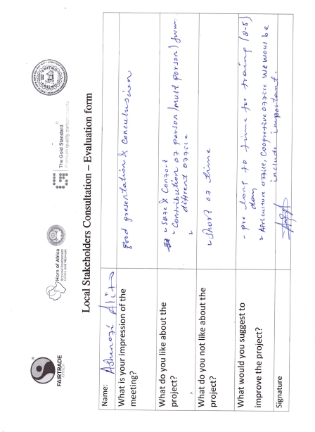

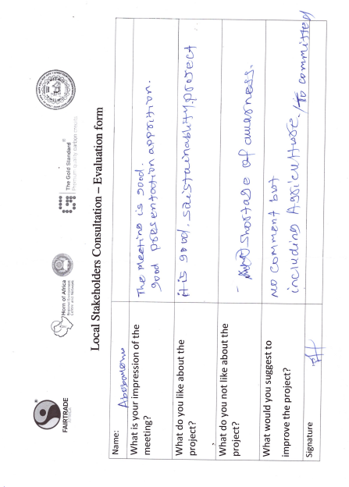

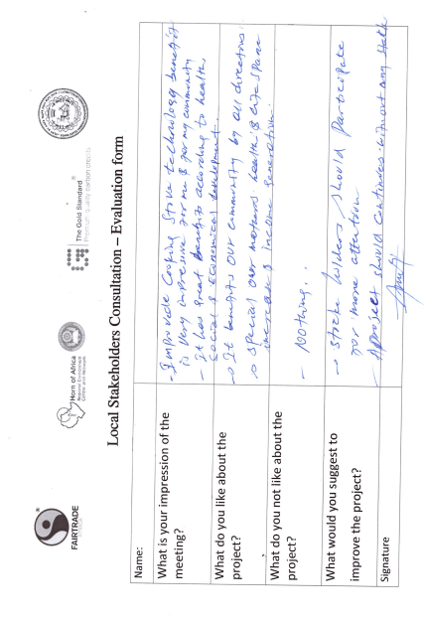

        - Summary of alterations based on comments
>>

Please use the table below to report on the methods agreed with stakeholders
      - CONTINUOUS INPUT / GRIEVANCE MECHANISM
 | Method Chosen (include all known details e.g. location of the book, phone, number, identity  of mediator) | Justification of Choice  (best practice)
Continuous Input / Grievance Expression Process Book (mandatory) | Continuous input/grievance  expression process book will be kept at Sidama Coffee Farmer Cooperatives Union Office located at Hawasa town | These locations were approved by stakeholders during the meeting
GS Contact (mandatory) | help@goldstandard.org
Telephone access (optional) | +251913016327 | Contact phone of the responsible person provided during consultation time.
Internet/email access (optional) | erm20430@gmail.com
Nominated Independent Mediator (optional)
Other

      - STAKEHOLDER FEEDBACK ROUND

☐ Please check this box if the project is retroactive and has done only 1 consultation with a physical meeting integrated into the SFR.

        - Length of the Feedback Round

Stakeholder Feedback Round |  | Planned | Actual
Start Date |  | ☐ | ☐
End Date |  | ☐ | ☐

        - Summarise how all stakeholders were/will be invited to provide feedback
>>
Feedback round consultation invitations were send to all stakeholders who were participated on the first consultation meeting. The invitation was made through formal letter, telephone calls and physical invitation through primary cooperatives networks.
        - Summarise Feedback received, including if any changes in project design were made
>>
The physical stakeholders feedback round consultation was s conducted on October 27, 2023, at Hawasa Lewi resort.
On the meeting the project design was presented in detail to the participants and the participants give their feedback and input on the project design. Some of the feedbacks given are summarized as follows:
- The way the project designed (stove distribution, emission reduction calculation, monitoring plan), the project positive effects on health, environment, expected carbon revenues, and indoor air pollution reduction was appreciated
- The participants inspired by the project design and decided to serve as models and begin the installation from their home.
- In terms of the incentive system, the cooperatives demonstrate a willingness to cover portion of the cost of the stove and support the installation
- Recommended that end users/farmers receive training and clarity regarding the payment process.
- Women participants appreciated the attention given to save the health. They showed their commitment to realize the project idea so that all women can benefit.
- The project design was approved by the producers, indicating that it has the potential to address the intended quantity of improved cook stoves.
From the received feedbacks, no changes in project design were made.

Revision History

Version | Date | Remarks
1.2 | 5 May 2022 | Addition of grouped consultation info, preliminary agenda and section to justify retroactive consultation took place.  Minor edits to text.
1.1 | 14 October 2020 | Inclusion of Key Project Information  Restructure, new headings and reorder to better match the steps a developer will follow in consultations.  Removal of some non-mandatory template tables (Blind Sustainable Development Assessment). Clarification of best practice steps that are non mandatory processes, clarification of mandatory discussion points. Clarification regarding publishing names and that original evaluation forms (optional) and attendance lists (mandatory) should be separate documents.  Improved clarity on Stakeholder Feedback round section and procedures for retroactive projects  Provision of an accompanying Guide to help the user understand detailed rules and requirements
1.0 | 14 August 2017 | Initial adoption

