**Horn of Africa Climate Change Program**

The Horn of Africa Climate Change Programme (HoA-CCP) is an initiative of Addis Ababa University – Horn of Africa Regional Environment Centre and Network (AAU-HoA-REC&N) The start up phase kicked off in November 2014 with support grant of € 4.000.000 from the Ministry of Foreign affairs (DGIS), Netherlands for a period of four years. The grant is being used as a leverage to attract other financial resources and sustain the regional programme.

The key implementing organizations are the Horn of Africa Regional Environment Centre (HoA-REC), under auspices of University of Addis Ababa and the Horn of Africa Regional Environment Network (HoA-REN), which comprises the National Focal Point Organizations from the participating countries in the Horn of Africa. HoA-REC serves as a secretariat of the Network.

[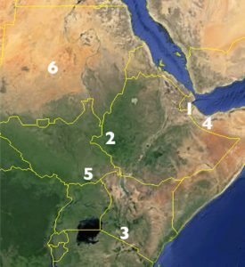](http://hoarec.org/wp-content/uploads/2016/11/hoaccp.jpg)

Horn of Africa Countries

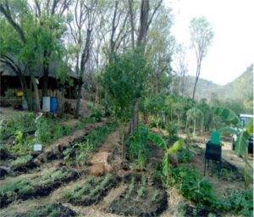

Climate smart Permaculture design field in EcoHub Gambella, Ethiopia

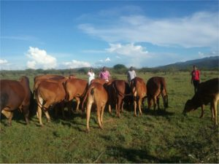

Climate smart cattle improved breeds in South Rift Landscape, Narok country, Kenya

* **1. Djibouti**

**Civil Society Focal Point** Association Djibouti Nature (ADN)  **Landscape** (Assamo landscape) 35,000 ha

* **2. Ethiopia (Eco-Hub)**

**Civil Society Focal Point:** HoA-REC-Gambella Branch Office (HoA-REC-GBO) **Landscape:** Eco-Hub-Gambella landscape 460 ha

* **3. Kenya**

**Civil Society Focal Point:** South Rift Association of Land Owners (SORALO) **Landscape:** South Rift Landscape (Kenya) 800,000 ha

* **4. Somalia**

**Civil Society Focal Point:** Barwaaqo Voluntary Organisation (BVO) **Landscape:** Somaliland/Somalia (Maroodi Jeex Landscape) 25,000 ha

* **5. South Sudan**

**Civil Society Focal Point:** South Sudan Nature Conservation Organisation (SSNCO)

* **6. Sudan**

**Civil Society Focal Point:** Sudanese Environmental Conservation Society (SECS) **Landscape:** Khor El Teena Landscape 82,602 ha

The Centre and the Network were formed in 2006 with the financial support of the Embassy of the Kingdom of the Netherlands (EKN). In 2010, the Centre was established as an independent regional institution under AAU. The Network consists of about 45 endogenous Civil Society Organizations (CSOs) and knowledge institutes (Academia) working on environmental governance and sustainable development together with communities, government, private sector and other CSOs as well as regional and international organizations.  HoA-REC and several HoA-REN members have relationships with Dutch institutions, ranging from business to universities.

The climate change programme promotes climate smart sustainable and inclusive development in Djibouti, Ethiopia, Kenya, Somalia (Somaliland), South Sudan and Sudan. It works through an integrated approach, focusing on land, water, value chains and renewable energy to enhance climate change adaptation and mitigation, and create ‘resilient landscapes’. It is implemented in strategic parts of (trans-boundary) river basins in the Horn of Africa. The programme uses an area-based approach to sustainable development and climate resilience.   The programme focus areas are:

* Promotion of landscape restoration through sustainable land and water management and natural resource conservation;
* Increased food security by promoting climate smart agriculture and green value chains;
* Reduction of green house gas emissions and improvement of livelihoods by promoting renewable energy and green infrastructure.