|  |
| --- |
| **http://www.google.com/images?q=tbn:ANd9GcSyO3a4GO8Z1YMnQMjq1vw3coRAFeYgb9_hc25b7ikj2hdDIGezV7pNfVg** |
| **ASSESSMENT OF USED VEGETABLE AND MOTOR OILS IN ADDIS ABABA** |
| Amount and Disposal Practices |
|  |
|  |

Horn of Africa Regional Environment Center and Network, AAU Sustainable Energy, CARBON AND Urban Resilience programme

2016

Table of Contents

List of figures

List of Anne’s

Acronyms

EXECUTIVE SUMMARY

1.INTRODUCTION 6

1.1.Background and Rationale 6

1.2.Objective of the assessment 8

1.2.1.General objective 8

1.2.2.Specific Objective 9

1.3.Limitation of the study 9

2.METHODOLOGY 10

2.1.Description of the Study Area 10

2.2.Data collection Technique 11

2.2.1.Data Sources and collection system 12

2.2.2.Sampling Technique 12

2.2.3.Data Entry and analysis 13

3.RESULT AND KEY FINDING 14

3.1.Used motor oil 14

3.1.1.Sources and amounts of used motro oil in Addis Ababa 14

3.1.2.Used motor oil disposal practice in Addis Ababa 15

3.2.Used vegetable oil 17

3.2.1 Sources and amounts of used vegetable oil in Addis Ababa 17

3.2.2. Used vegetable oil disposal practice in Addis Ababa 18

3.3.Current regulations, guidance and management scenarios of used oil in Addis Ababa………………….. 20

3.4.Comparative study and Existing status of used oil Recycling in Addis Ababa 20

4.CONCLUSION……………. 23

5.RECOMMENDATION 24

6.REFERENCES.. 25

7.ANNEX……………………………………………………………………………………………………………………… 27

**List of figures**

Figure 1: Addis Ababa Map

Figure2:.Data collection method

Figure 3: UMO generating from each garages and fuel stations in AA in litter per month

Figure 4: percentage of UMO disposed and reused

Figure 5: used motor oil disposal practice

Figure. 6: UMO storage mechanism

Figure 7: Vegetable/cooking oil consuming in AA by each hotels, cafes and restaurants

Figure 8: UVO generating in AA from each hotels, cafes and restaurants per month

Figure 9: Percentage of UVO disposed and reused

Figure 10: UVO disposal practice

Figure 11: biodiesel production from used vegetable oil pilot project workshop and products

**List of Anne’s**

Annex 1: sample size stratified by sources of used vegetable and motor oil

Annex 2: Garages and fuel station employee size

Annex 3: Descriptive of UMO generated in each garages and fuel station monthly

Annex 4: Frequencies of UMO dispose, reuse and both

Anne 5: Frequencies of Purpose of UMO reuse

Annex 6: Frequencies of UMO disposal practice

Annex 7: Frequencies of UVO generators employee size

Annex 8: Descriptive of Amount UVO generating from each small, medium and big hotels, cafes and garages per month

Annex 9: Frequencies of UVO Dispose, reuse or both

Annex 10: Frequencies of UVO reuse purpose

Annex 11: Frequencies of UVO disposal practices

Annex 12: Questionnaires

**Acronyms**

AA Addis Ababa

AAEPA Addis Ababa Environment protection Authority

AASBPD Addis Ababa sanitation, beatification, park and cemetery

AATB Addis Ababa Trade bureau

B-50 50% biodiesel and 50% diesel

NME New Zeeland ministry of the Environment

UNEP United Nations Environment programme

U.S.EPA U.S. Environmental protection Authority

UMO Used motor oil

UVO Used Vegetable Oil

**EXECUTIVE SUMMARY**

Used oil is mineral or synthetic oil contaminated by physical or chemical impurities and that has impacts on human health and environment. In this assessment, the amount and disposal practices of used vegetable oil (UVO) and motor oil (UMO) in Addis Ababa were identified. The data was collected from the different sources of UVO and UMO such as hotels, cafes, restaurants, garages and fuel stations in Addis Ababa. Garages, hotels, cafes, fuel stations and restaurants were stratified and Qausi- randomly selected using probability sampling method and after data collection, based on the number of employees, the data was categorized in to small, medium and big levels.

The assessment revealed that, there are enormous amount of UVO and UMO that has been generating from automotive service and food service establishments in Addis Ababa; however, the disposal practices are not environmentally sound. From each small, medium and big garages and fuel stations in the city; 399.7, 1418.7 and 2750.8 liters of UMO are being generated per month respectively (approximately **3.7 million** liters of used motor oil are being generated/estimated monthly in AA). On the other hand; from each small, medium and big hotels, cafes and restaurants on average 125, 56, and 35 liters of UVO are being generated per month respectively. Approximately, on average more than **900,000** liters of UVO estimated to be generated monthly in Addis Ababa.

Regarding used motor and vegetable oil disposal practices, from generated used motor oil in the city, 94% is disposed, 4% is both disposed and reused and only 2% of used oil is reuse. 87% of the used motor oils generated in Addis Ababa is get rid of through sale to other organizations or individuals with the price of 3 birr and 60 cents per litter on average and the remaining percent of UMO are pouring in the sewers and provide for any enterprises or individuals without any fee. It is notices that, the generator companies know the clients purpose of UMO, which may include but not limited to; for heating/burning at low temperature, machine lubrication in factories and for varnish making. The assessment also revealed that, from generated UVO in Addis Ababa, about 99% are disposed through pouring in sewers, ground, and toilet, remove with solid waste and provide for homeless children’s whereas only 1% of the UVO are sale for biodiesel production enterprise. Some of hotels, cafes and restaurants are reused the UVO for frying and cooking again.

The Assessment also analyzes the existing potential of biodiesel production from UVO and UMO. Based on the percentage of Biodiesel production from UMO and UVO, the assessment estimates **3.8 million litters** of Biodeisel production in Addis Ababa monthly and which could be reduced 10.6 million kg of CO2  emission released from petroulem Diesel and national cost of disiel import by______$ in month . The assessment also observed that, existing policies, regulations and guidance of used oil management in the city. According to this assessment, at present time there is not clear policy in place for the management of used oils in the country. However, the AAEPA has developed used oil management guideline for voluntary use and do not enforce mandatory use for both used oil generators and users as well inspectors.

From the assessment, it is recommend that, the government need to formulate and implement policies, law and regulation or bylaws to manage the used oil and promote the recycling of used oil. As well, the government should monitor and conduct continuous awareness creation programs for all stakeholders involved in UMO and UVO use and disposal to prevent environmental pollution and impact on human health. It is also recommends that, more industry and businesses should be set up as facilities to recycle used oil or convert used oil to energy.

# INTRODUCTION

## Background and Rationale

According to New Zeeland ministry of the Environment (2000), used oil is defined as mineral or synthetic oil contaminated by physical or chemical impurities through use as a lubricant, or similar function, to the point where it is no longer fit for its original purpose. Its chemical composition will vary according to source and purpose, and the use to which it has been put. The U.S. EPA also defines, Waste (used) oil is any oil that has been refined from crude oil or any synthetic oil that has been used and as a result of such use is contaminated by physical or chemical impurities. Simply put, used oil is exactly what its name implies any petroleum-based or synthetic oil that has been used. During normal use, impurities such as dirt, metal scrapings, water, or chemicals can get mixed in with the oil, so that in time the oil no longer performs well (UNEP,2012).

Used vegetable oil” (UVO) refers to vegetable oil which has been used in food production and which is no longer viable for its intended use. Used vegetable oil arises from many different sources, including domestic, commercial and industrial (Refaat, A. A., 2010). used motor oil (UMO) is also generated in the various types of facilities like garages, new car dealer showrooms, fuel stations, other retail establishments and automotive fleet service areas (UNEP, 2012) and it has hazardous properties including flammability, toxicity and Eco toxicity (NME, 2000).

In highly industrialized regions, considerable amount of Used Oils is available from trucking, transportation, and construction company fleets and food service establishments.

The production of Used automotive engine oil is estimated at 24 million tons each year throughout the world, posing a significant treatment and disposal problem for modern society (Mohd, N.N., *et al* 2014 ; Naima, K. and Liazid,A., 2013). Several billions of gallons of waste vegetable oil are also produces every year around the world, mainly from industrial deep fat fryers found in potato processing plants, factories manufacturing foods, and restaurants ( Tamilselvi, K. & Punitha,U., 2015). Asia accounts for almost 30% of global used oil generation followed by North America at 22%. It is estimated that globally only about 50% (i.e. about 20million tons) of the used oil is collected systematically (UNEP, 2013)**.**

The contaminants in used motor and vegetable oils have adverse environmental and health impacts and that requires responsible management (UNEP, 2012). It may cause damage to the environment when dumped into the ground or into water streams including sewers. This may result in groundwater and soil contamination. The oil, which reaches the water sources, increases its organic pollution load, to form layers on the water surface to prevent the oxygen exchange and alters the ecosystem. The dumping of the oil also causes problems in the pipes drain obstructing them, creating odors, and increasing the cost of wastewater treatment. For this reason, has been necessary to create a way to recover this oil and reuse it. Also due to the wear and tear resulting in sewer pipes may cause overflows of the system, "generating diseases that can cause mild stomach cramps to diseases potentially fatal, such as cholera, infectious hepatitis and gastroenteritis, due to the sewage contains water which can transport bacteria, viruses, parasites, intestinal worms and molds” (Hamawand,I.*et al*,2013 ; Jhanani. S. and Kurian J. , 2011).

These used oils need a serious management to prevent pollution. The management options for used oil include re-refining, reprocessing and various forms of disposal (Bob Boughton, 2004). A recommended solution for this issue is the reuse or recycling of the used oil in to different products such as biodiesel and others using the different methods like Acid / Clay re-fining, Vacuum Distillation/Evaporation Technology, Hydrogenation Based Technologies, By-products of the Process, Ultra-Filtration Technology, Extraction based Technologies and others (Ahmad, J.J.and Malek, H.R., 2014 ; UNEP,2012).

## Ethiopia is currently on the edge of rapid economic development and according to the World Bank, 2014; the population growth in Ethiopia is measured at 2.51% annually. The number of automobile and food service establishments becomes increases year to year in the country, especially in the capital city of the country Addis Ababa. This is the main source for the generation of used vegetable and motor oils in the city. Currently in Addis Ababa more than 17, 900 service provider organizations like hotels garages, cafes, restaurants, and fuel stations exists and are generating a number of used vegetable and motor oil in the city. In 2012 the total number of vehicles in Addis Ababa is 167,391 that accounts to 75% (130,000-140,000 vehicles) of vehicles that was present in 2008 in the city (AASBPD, 2003). 53% vehicles are more than 20 years old, and low engine efficiency, consume excess fuel, and are potential sources of GHG emissions, cars depreciates due to long time service and requires frequent maintenance.

The sustainable management of this generated used UVO and UMO demands the formulation and enforcement of legislations and regulations. Addis Ababa EPA is the right Authoritative body /organization to manage the used oil in the city, however there is not clear policy and regulation of the used oil management in the country at the stake except environmental policy and environmental pollution control proclamation. The Environmental Pollution Control Proclamation Proc. No. 300/2002, says, "No person shall pollute or cause any other person to pollute the environment standard". Under this proclamation, Addis Ababa Environmental Protection Authority as competent authority has the duty to issue permit in relation to the importation, preparation, keeping, distribution, storage, transportation or use of a chemical categorized as hazardous or of restricted use.

## Objective of the Assessment

### General Objective

To identify the amount of used oil that is being generated in Addis Ababa and the current disposal practices to make recommendations for alternative uses of the disposed oils.

**Specific Objective**

* To assess the amount of used vegetable and motor oil that is being generated in Addis Ababa,
* To assess the current used vegetable and motor oil disposal practices conducted within the service provider organizations,
* To assess the existing used oil management practices, rule and regulation,
* To review comparative studies and existing potential of Biodiesel production from used oil, and
* To recommend alternative options of use the used oil

## Limitation of the study

This assessment was based on the information provided by the used vegetable and motor oil generators or service provider’s organizations namely: hotels, cafes, Restaurants, fuel stations and garages. During the data collection period, it was not possible to conduct a detail inspection of the surveyed service provider’s organizations for observation and clarification of the used oil generated, especially in the used vegetable oil generators establishments. In addition, the amount of used oil generated especially in hotels, cafes, restaurants were not documented, and more of the data was estimated from the amount of oils uses for frying.

Moreover, some of the surveyed service providers organizations and individuals were not willing to cooperate and in providing reliable information and others posed a bureaucratic challenge, which took more than two weeks and could not address the targets of finalize sample size on planned time.

# METHODOLOGY

## Description of the Study Area

Addis Ababa is the Federal Capital City and the seat of the Federal Government and Parliaments. The City has gained international status by being the seat of the African Union (AU), several international organizations and numerous embassies. Geographically, Addis Ababa is located between 8055’and 90 0 5’ N Latitude and 380 40’ and 38050’ E Longitude. The city is located at the center of Ethiopia with an area of 540 km2 of which 18,174 m2 is rural and its altitude ranges from 2000m - 2800m. Addis Ababa has a subtropical highland climate. The city has a complex mix of highland climate zones, with temperature differences of up to 10 °C (18 °F), depending on elevation and prevailing wind patterns. The high elevation moderates temperatures year-round, and the city's position near the equator means that temperatures are very constant from month to month.

According to the new Census (2007), the current size of the population is 3,147,000, of which 1,511,000 is men and, 636,000 is women with eight percent annual growth rate and density of 5936.2/km2. According to official statistics from the federal government, some 119,197 people in the city are engaged in trade and commerce; 113,977 in manufacturing and industry; 80,391 homemakers of different variety; 71,186 in civil administration; 50,538 in transport and communication; 42,514 in education, health and social services; 32,685 in hotel and catering services; and 16,602 in agriculture. In addition to the residents of rural parts of Addis Ababa, the city dwellers also participate in animal husbandry and cultivation of gardens. 677 hectares (1,670 acres) of land is irrigated annually, on which 129,880 quintals of vegetables are cultivated. The city of Addis Ababa is divided into ten administrative zones called Sub-Cities, such as Bole, Nifas silk lafto, Arada, Gullele, Yeka, Kolfe keraniyo, Akaki Kaliti, Lideta, Addis Ketema and kirikos.

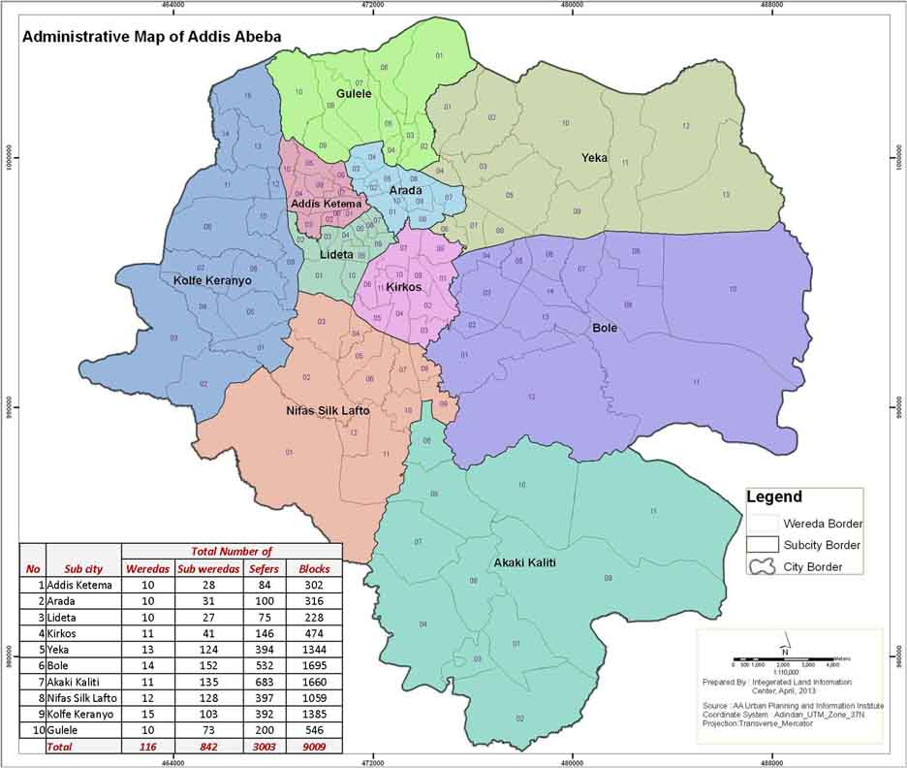

Figure 1: Addis Ababa Map

## Data collection Technique

The methodology used for the study is depicted in Figure 2. The list of various industries generating used oil was obtained from Addis Ababa Trade Bureau (AATB).

Figure 2: Data collection method

### Data Sources and collection system

All required data for this study were collected both from primary and secondary sources. Primary data information was generated from different garages, hotels, cafes, fuel stations, restaurants, and Addis Ababa Environment protection Authority (AAEPA). Secondary data was gathered by review of different documents. The data collection was done using Questionnaire, personal discussion, observation and Key informant Interview. In order to make the questionnaire appropriate for informer and to gathered more necessary data and eradicate miss of information’s , Three hotels, cafes, restaurants, fuel stations and garages were selected from each respectively and pilot test of questionnaire was conducted. Subsequently, the questionnaire was refined and developed for data collection from the selected hotels, cafes, restaurants, fuel stations and garages in Addis Ababa. The supportive data was collected Qausi-randomly from hotels, cafes, restaurants, fuel station and garages in all sub-cities and after the data was collected, based on the number of employees of the company, the hotels, cafes, restaurants, garages and fuel stations were categorized in to small, medium and big level.

### Sampling Technique

The study employed a range of sampling techniques including stratified and Qausi random sampling. Garages, hotels, cafes, fuel station and restaurants were stratified and Qausi- randomly selected using probability sampling method (See Annex: 1). the formula to calculate sample size where key indicators expressed as percentages is:

$$s=\frac{x^{2}NP\left(1-P\right)}{d^{2}\left(N-1\right)+x^{2}P\left(1-P\right)}$$

Where; S = the desired sample size,

X2= the table value of Chi-square for 1 degree of freedom at the desired confidence level (3.8416)

N= the population size (17981)

P= the population proportion (assumed to be 0.5 since this would provide the maximum sample size)

d= the degree of accuracy expressed as a proportion (.05). The total sample size for the proposed assessment becomes 376.

**Proportionate**

Procedure: Stratify the population based on type of oil sources

### Data Entry and Analysis

SPSS software was used for data entry and analysis. After the data entry was finalized, the data was cleaned by checking any error or outliners and cross checking it with the original questionnaire. Then the final cleaned data was analyzed using SPSS software. Information gathered from qualitative sources was summarized and presented in form of narratives, while quantitative results are presented using descriptive statistics like percentages, frequency tables and averages.

# RESULTS AND KEY FINDINGS

# Used Motor Oil

### Sources and Amounts of Used Motor Oil in Addis Ababa

To determine the amount of used motor oil that is being generated in Addis Ababa, data was collected from different garages and fuel stations. In Addis Ababa, more than 2865 garages and 270 fuel stations are available. Approximately, on average 134 vehicles are services monthly in each garages and fuel stations. Based on the sampling, the data was collected from 78 garages and fuel stations that were 42 small, 18 medium and 18 big (see annex 2). The results of the analysis are presented in figure 3.

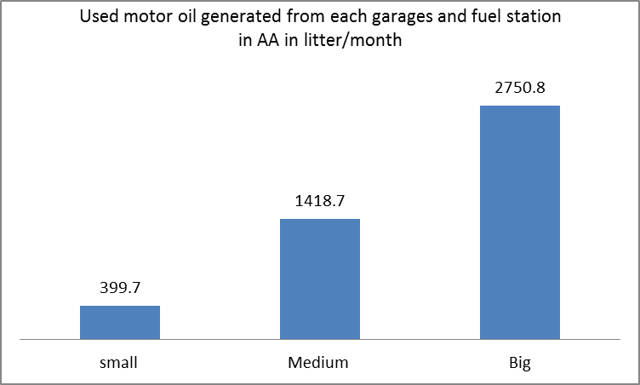

Figure 3: UMO generating from each garages and fuel stations in AA in litter per month

Figure 3 revealed that, the amount of used motor oil that is being generated in Addis Ababa. From each small, medium and large garages and fuel stations, on average, 399.7, 1418.7 and 2750.8 litter of used motor oils are being generated per month respectively. This means in Addis Ababa approximately on average **3.7 million** litters used motor oil expected monthly.

### Used motor oil disposal practice in Addis Ababa

The percentages of the used motor oil disposed and reused in Addis Ababa are presented in figure4.

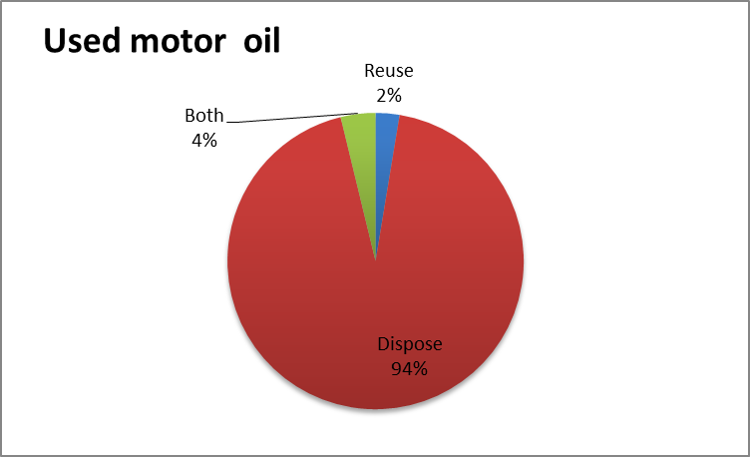

Figure 4: percentage of UMO disposed and reused

As Figure 4 shown that, from generated used motor oil in Addis Ababa, 94% is disposed, 4% is both disposed and reused and only 2% is reused. 40% of garages and fuel stations reuse the used motor oil for varnish and the remaining garages and fuel stations reuse for others, like for dust prevention and lubrication purpose.

Figure 5 revealed that, the disposal practices of used motor oil generated in Addis Ababa. 87% of the used motor oil generated in the city is get rid of through sale to other organizations or individuals with the price of 3 birr and 60 cents per litter on average and the remaining percent of UMO is disposed through pouring in the sewers and through provision of interested enterprises and individuals without pay. From each garages and fuel stations on average approximately 1921 litter of UMO has been sold per one selling event. Out of the total sales from garages and fuel stations, only 20 percent of transactions have contractual agreement. In addition only 51% of the generator companies know the clients purpose of UMO which may include but not limited to; for heating/burning at low temperature, machine lubrication in factories and for varnish making.

Figure 5: used motor oil disposal practice

95% of the used motor oil generators such as garages and fuel stations store the generated UMO in metal drum, 4% in plastic drum and 1% in others means like building concrete in the ground. Figure 6 shows us the storage mechanisms of generated UMO in garages that is not proper and some of the used oils are pouring on flour and in the ground.

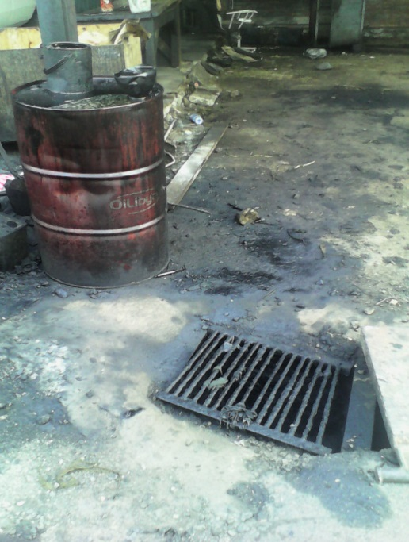 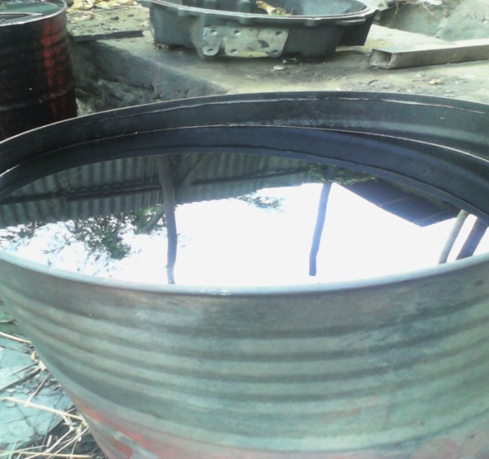

Figure 6: UMO storage mechanism

The assessment shown that, the used motor oil generated in Addis Ababa are not collected and stored properly and hence gets lost in sewers and drainage channels. It is also notes that there is an open burning practice and it becomes a source of air pollution in the form of particulate matters and others. As well, as most of the garages are located in residential areas, the problem is a major health threat to the surrounding residents.

## Used Vegetable Oil

### 3.2.1 **Sources and Amounts of Used Vegetable Oil in Addis Ababa**

The empirical data was collected based on the sample size determined and the amount of used vegetable oil was estimated from the amount of vegetable /cooking oil consumed by each hotels, cafes and Restaurants. In Addis Ababa approximately around 1765 hotels, 7587cafes and 5493 restaurants are available and based on the sampling, the data was collected from 143 small, 73 medium and 63 big hotels, cafes and restaurants (see annex:7). The results of analysis are presented below.

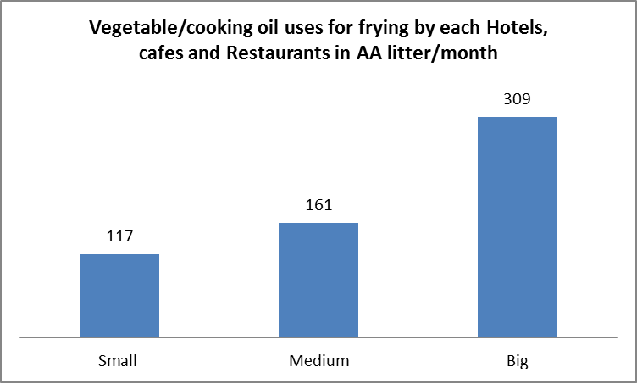

Figure 7: Vegetable/cooking oil consuming in AA by each hotels, cafes and restaurants

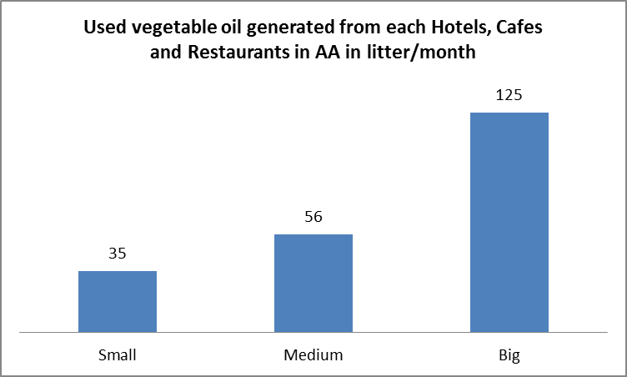 Figure 8: UVO generating in AA from each hotels, cafes and restaurants

Figure 7 revealed that, the amount of vegetable oil that has been consuming for frying by each small, medium and big hotels, cafes and restaurants in litter per month. In each small, medium and big hotels, cafes and restaurants, on average 117, 161 and 309 litters of Vegetable or cooking oil are being consumed per month respectively (approximately on average, 2.6 million litter of Vegetable/ cooking oil are being consumed monthly in Addis Ababa).

As figure 8 shows us, the amount of UVO that are being generated from each small, medium and big hotel, cafes and restaurants in Addis Ababa are on average 125, 56 and 35 litter per month respectively. In the city, approximately, on average more than **900,000** liters of UVO are being generated monthly.

### 3.2.2**. Used Vegetable Oil Disposal Practice in Addis Ababa**

The disposal practices of UVO generated in Addis Ababa result are presented below.

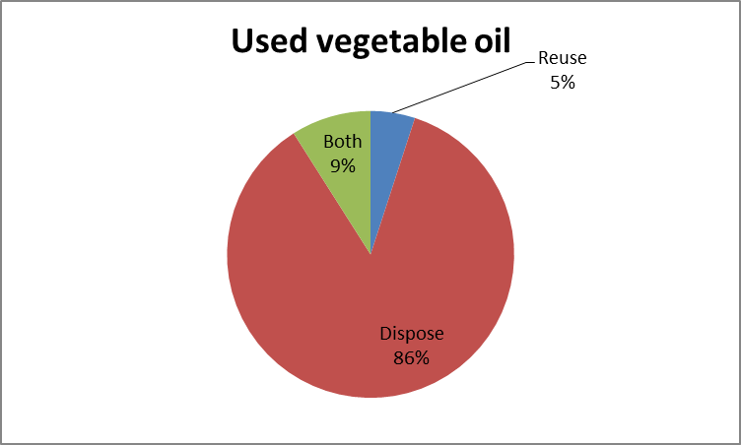

Figure 9: Percentage of UVO disposed and reused

Figure 9 revealed that, the percentage of the used Vegetable oil disposed and reused in Addis Ababa. From generated UVO about 86% is disposed or get rid of, 9% is both disposed and reused and only 5% of used oil is reuse. 52.5% and 27.5% of hotels, cafes and restaurants are reused the UVO for frying and cooking again respectively, whereas 20% of hotels, cafes and restaurants are reuse the UVO for heating.

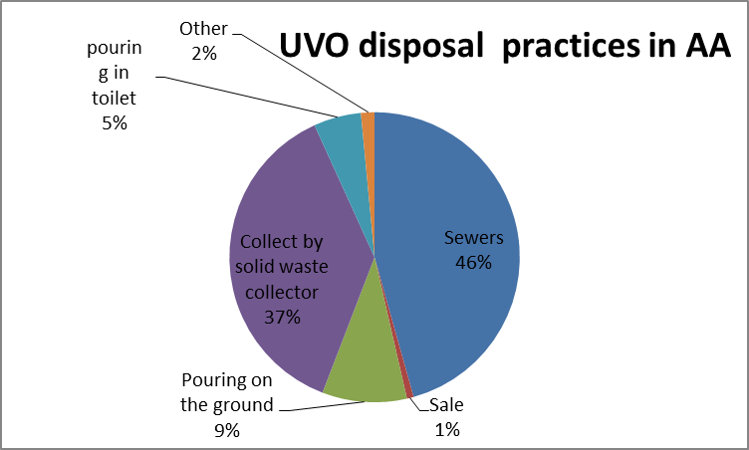

Figure 10: UVO disposal practice

As figure 10 shows us, 46%, 9% and 5% of used vegetable oil generated in Addis Ababa are pouring in sewers, ground and toilet respectively whereas 37% of the UVO is collected by solid waste collectors by store it in the container or pouring away in the solid waste bin. Only 1% of generated UVO is sale for Biodiesel Production Company with the price of 0.5 cents per litter and on average from each hotels, cafes and Restaurants approximately 198 litters has been sold per one selling event. The remaining share is providing to homeless children and others people in need.

Before disposed the used vegetable oil, 51% and 20% of the UVO generators are store the used oil in plastic container and metal container respectively. However, the reaming hotels, cafes and garages are disposed away directly.

The results shown that, 99% of the used vegetable oil disposal practices in Addis Ababa are not in environmentally sound method.

## Current Policy, Regulations, Guidance and Management Scenarios of Used Oil in Addis Ababa

For the management of used oil generation and use EPA is the right concerning body, through key informant interview with AAEPA, the current used oil management scenarios and the existing policy, regulation, bylaw or any guidance was determined. The AAEPA environmental pollution impact monitoring and control core process head explained that, the used oil management or pollution control, like inspection is conducted in collaborating with sub cites and woredas EPA, however they have been inspecting only the used oil generated from Garages. The AAEPA core process head also mentioned that, there is no specific policy, law and regulation for used oil management rather than environmental policy and Environmental pollution control proclamation. However, the AAEPA has developed used oil management guideline (GG Consultancy Service, 2014) for voluntary use and do not enforce mandatory use for both used oil generators as well inspectors.

* 1. **Comparative study and Existing status of used oil Recycling in Addis Ababa**

Currently one of Biodiesel production plc, which is located in Addis Ababa, has been working on the pilot project of producing biodiesel from used vegetable oil. The project owner has been collecting the UVO from five stars hotels in Addis Ababa and the pilot project has the potential of producing 250 liters of biodiesel in 8 hours per day using Tran’s esterification method. The percentage of biodiesels is 80 to 90% (i.e. 80% biodiesel and 20% Glycerin; 90% biodiesel and 10% Glycerin). In addition, the plant recycles the glycerin in to soap and uses the byproduct during used oil filtration as compost. The reactor is manufactured in house by the project owner and the produced biodiesel has been used by ISUZU automobiles with a 50% biodiesel and 50% Diesel (B 50) blend.

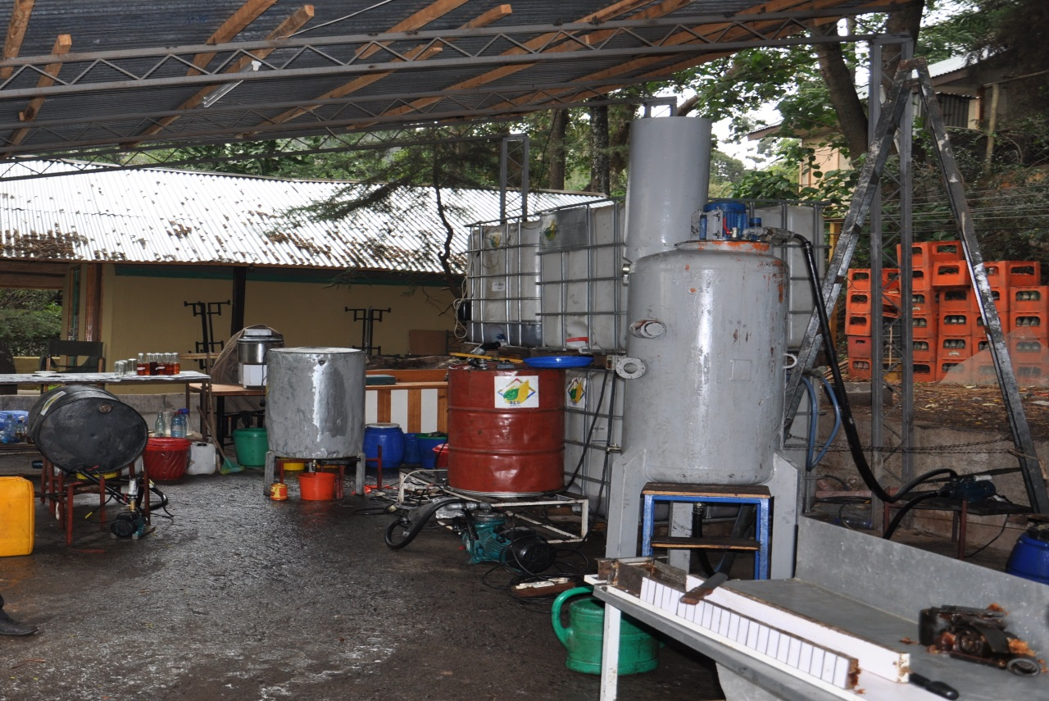

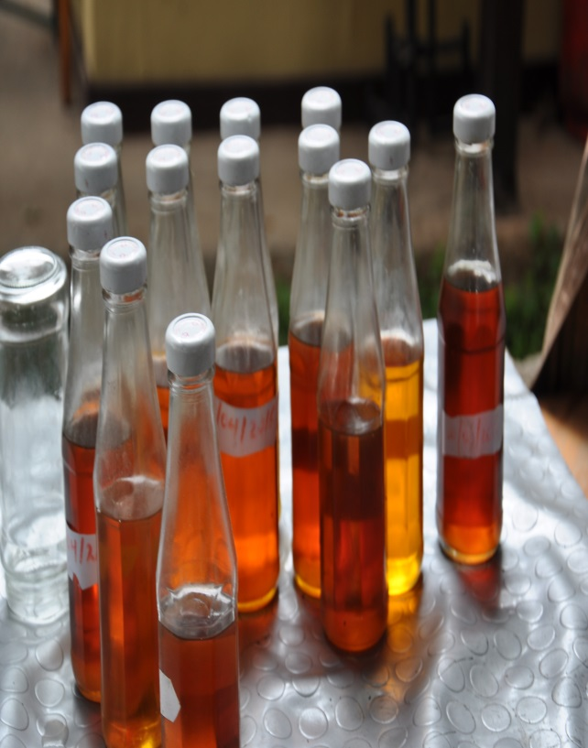 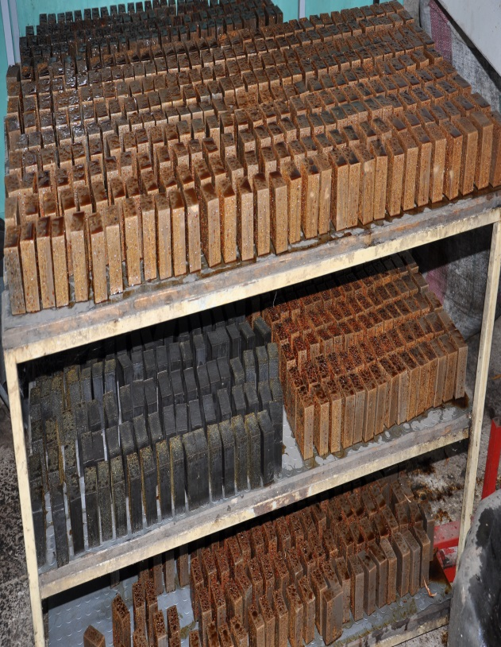

Figure 11: biodiesel production from used vegetable oil pilot project workshop and products

UVO and UMO has the potentail of biodiesel production using the different method and treatment. According to the present pilot project of biodiesiel production from UVO in Addis Ababa and the differrent studies on the bidiesel production from UVO, the percentage of biodeseil are on average 80 to 90%; 88.5% (yaekob,2011) ; 99.5% (Alemayehu and Abile 2014). The percentage of Biodiesel production plant from UVO in South Africa, USA, Germany and Brazil are 94%, 96%, 96% and 95% respectively (Mbohwa, C. and Alexander Mudiwakure, A., 2013). As well, the percentage of biodiesel from UMO are 80% and 82% (Hamawand,I. *et al*,2013;Naima, K. and Liazid,A., 2013). Thereofre, Based on the amount of used vegetable and motor oils determined in this assessment and the potential of UVO and UMO for biodeisel production, monthly on average **810,000** and **3 million litters** of Biodeisel production could be estimated respectively. It has the potential of reduce 10.6 million kg of CO2  emission released from petroulem Diesel and reuduce national cost of disiel import by______$ in month .

# CONCLUSIONS

In this assessment, the amount and disposal practices of the used vegetable and motor oils in Addis Ababa were indenfied . From the assessment, the amount of used motor oils that are being generated from each small, medium and big garages and fuel stations in Addis Ababa are 399.7, 1418.7 and 2750.8 liter per month respectively (approximately **3.7 million** liters of used motor oils are being generated/estimated monthly in AA). Most of garages and fuel stations in the city are get rid of the UMO through sale to others organizations and individuals with the price of 3 birr and 60 cents per litter on average for the different purposes like use for heating and Lubrication of factories machineries. Only 2% of garages and fuel stations uses the used motor oil for varnish, dust prevention and lubrication purpose. Some garages and fuel stations are pouring the UMO in the sewers and drainage channels and most of them store the UMO in metal drums. However this handling method is not proper and some of the oil is spilled on the ground and on the flour which is so harmful for environment like ground water pollution.

The amount of Used Vegetable oil that are being generated from each small, medium and big hotels, cafes and restaurants in the city are, on average 125, 56, and 35 liters per month respectively. Approximately, on average more than **900,000** liters of UVO are being generated /estimated in Addis Ababa monthly. From generated UVO, about 99% are disposed through pouring in sewers, ground, and toilet, remove with solid waste and provide for homeless children’s and only 1% of the UVO is sale for biodiesel production enterprise. Some of hotels, cafes and restaurants are reused the UVO for frying and cooking again. Currently in Addis Ababa, pilot project of biodiesel production from UVO enterprise is producing 80 to 90% of biodiesel and the assessment was also reviewed some of international biodiesel production from UMO and UVO and estimated the production of 3.8 million liters of biodiesel from UVO and UMO per month.

The assessment was also identified existing policy, law and regulations, bylaw or guidance AAEPA uses to manage used oil generating in Addis Ababa. Except one guideline developed for used oil management, there is not clear policy; law, regulation, and bylaw in place, which clearly states the mandates and responsibilities of EPA and used oil generators.

The assessment shows the amount of UMO and UVO generated in Addis Ababa is enormous. In addition, it is conclude that, the disposal practice of the UMO and UVO are not in environmentally sound manner. Therefore collection of this used oils properly and recycle in to energy or biodiesel make the UMO and UVO environmentally friend waste recycling and it has also the potential of reduce tones of C02 emission released from petrol diesel and reduce national cost of import fuel.

# RECOMMENDATIONS

# Based on the present assessment the following recommendations are forwarded:

# Governments:

# Should formulate and implement policies, law and regulation or bylaws to manage the used oil and promote the recycling of used oil or its conversion into a source of energy. This can lead to the establishment of “green industry”, thus creating “green jobs” which can provide additional income to waste oil generators and reduce national import fuel.

# Must also intensify its visits to the used oil generators and users organizations, educate, and sensitize the mechanics about the health and environmental effects of used oils.

* More industry and businesses should be set up as facilities to recycle used oil or convert used oil to energy. The raw material (used oil) is widely available locally and the market for the product (energy or biodiesel) is quite wide. The size of the facility will depend on the investment capability, availability of used oil and the market for Energy.

# REFERENCES

1. Addis Ababa city Sanitation, Beautification and Parks Development Agency, report 2003
2. Alemayehu Gashaw and Abile Teshita,(2014). Production of Biodiesel from Waste Cooking Oil and Factors Affecting Its Formation: A Review.*International Journal of Renewable and Sustainable Energy.* Vol. 3, No. 5, 2014, pp. 92-98. doi: 10.11648/j.ijrse.20140305.12
3. Ahmad, J.J.and Malek, H.R, (2014). Survey of economic indices of the used motor oil. s.l. : Merit Research Journal of Engineering, Pure and Applied Sciences, 2014, Vol. Vol. 2(2) 2014.
4. Bob Boughton., (2004). Environmental Assessment of Used Oil.. USA : Environmental Science and Technology, 2004. DOI: 10.1021/es034236p.
5. Federal Democratic Republic of Ethiopia population Census Commission. Summary and Statistical Report of the 2007 Population and Housing Census, December 2008 Addis Ababa.
6. GG Consultancy Service, (2014). Guideline for Waste/Used Oil Management in Addis Ababa, Addis Ababa Environmental Protection Authority, Addis Ababa, Ethiopia,
7. Hamawand ,I. ; Talal Y. and Sardasht R., (2013). Agent, Recycling of Waste Engine Oils Using a New Washing. 2013. iraq : energies,. ISSN 1996-1073.
8. Jhanani. S. and Kurian J.,( 2011). Used oil generation and management in the automotive industries: international journal of applied engineering research, dindigul, Vols. Volume 2,. ISSN 09764259. No 1, India
9. Mbohwa, C. and Mudiwakure, A. (2013). The status of used vegetable oil (UVO) biodiesel production in South Africa. Proceedings of the World Congress on Engineering 2013 Vol I, WCE 2013, July 3 - 5, 2013, London, U.K.
10. Mohd. Nematullah Nasim, M. Sohail Pervez,Ravindra Babu Yarasu, Namrata V Lotia., (2014). India : IOSR Journal of Mechanical and Civil Engineering (IOSR-JMCE), 2014. e-ISSN: 2278-1684, p-ISSN: 2320-334X.
11. Naima, K. and Liazid,A., 92013). Waste oils as alternative fuel for engine diesel. Algeria : Journal of Petroleum Technology and Alternative Fuels, 2013, Vols. Vol. 4(3),.
12. New Zealand Ministry of Environment (2000), Used Oil Recovery, Reuse and Disposal in New Zealand: Issues and Options: available on the Ministry for the Environment’s web site at www.mfe.govt.nz
13. Refaat, A. A., (2010). Different techniques for the production of biodiesel from waste vegetable oil. Int. J. Environ. Sci. Tech., 7 (1), 183-213.
14. Tamilselvi, K. & Punitha,U., (2015). Production of biodiesel from beef fried oil. Issue (1), pp:144-149, India : nternational Journal of Innovation in Pharma, 2015, Vols. Volume2,. ISSN: 2349-865X.
15. UNEP, (2013), International Environmental Technology Centre, Policy Brief on Waste Oil What, Why and How
16. UNEP (2012), compendium of recycling and destruction technologies for waste oils
17. World bank, (2014), http://www.tradingeconomics.com/ethiopia/population-growth-annual-percent-wb-data.html
18. Yaekob Kebede (2011). Waste cooking oil resource assessment as alternative or biodiesel production, Addis Ababa University,unpublished

# ANNEX

Annex 1: sample size stratified by sources of used vegetable and motor oil

|  |  |  |  |
| --- | --- | --- | --- |
| Oil Source | # of sources | Proportion of total | # in sample |
| Café | 7587 | 42% | 158 |
| Restaurant | 5493 | 30% | 115 |
| Hotel | 1765 | 10% | 37 |
| Sub Total | 14845 | 82% | 310 |
| Garage | 2865 | 16% | 59 |
| Fuel station | 271 | 2% | 7 |
| Sub Total | 3136 | 18% | 66 |

Annex 2: Garages and fuel station employee size

|  |  |  |
| --- | --- | --- |
| **Statistics** | | |
| Employeesize | | |
| N | Valid | 78 |
| Missing | 0 |

|  |  |  |  |  |  |
| --- | --- | --- | --- | --- | --- |
|  | | | | | |
|  | | Frequency | Percent | Valid Percent | Cumulative Percent |
| Valid | Small | 42 | 53.8 | 53.8 | 53.8 |
| Medium | 18 | 23.1 | 23.1 | 76.9 |
| Big | 18 | 23.1 | 23.1 | 100.0 |
| Total | 78 | 100.0 | 100.0 |  |

Annex 3: Descriptive of UMO generated in each garages and fuel station monthly

|  |  |  |  |  |  |
| --- | --- | --- | --- | --- | --- |
|  | | | | | |
| Employee size | | N | Minimum | Maximum | Mean |
| Small | Q3month | 42 | 9.00 | 2520.00 | 399.7857 |
| Valid N (listwise) | 42 |  |  |  |
| Medium | Q3month | 18 | .60 | 5520.00 | 1418.7000 |
| Valid N (listwise) | 18 |  |  |  |
| Big | Q3month | 18 | 450.00 | 9600.00 | 2750.8333 |
| Valid N (listwise) | 18 |  |  |  |

Annex:4. Frequencies of UMO dispose, reuse and both

|  |  |  |
| --- | --- | --- |
| **Statistics** | | |
| Reuse or Dispose or both | | |
| N | Valid | 78 |
| Missing | 0 |

|  |  |  |  |  |  |
| --- | --- | --- | --- | --- | --- |
| **Reuse or Dispose or both** | | | | | |
|  | | Frequency | Percent | Valid Percent | Cumulative Percent |
| Valid | Reuse | 2 | 2.6 | 2.6 | 2.6 |
| Dispose | 73 | 93.6 | 93.6 | 96.2 |
| both | 3 | 3.8 | 3.8 | 100.0 |
| Total | 78 | 100.0 | 100.0 |  |

Annex:5. Frequencies of Purpose of UMO reuse

|  |  |  |  |  |  |
| --- | --- | --- | --- | --- | --- |
| **Purpose of reuse** | | | | | |
|  | | Frequency | Percent | Valid Percent | Cumulative Percent |
| Valid | Varnish | 2 | 40.0 | 40.0 | 40.0 |
| other | 3 | 60.0 | 60.0 | 100.0 |
| Total | 5 | 100.0 | 100.0 |  |

|  |  |  |
| --- | --- | --- |
| **Statistics** | | |
| Purpose of reuse | | |
| N | Valid | 5 |
| Missing | 0 |

Annex: 6. Frequencies of UMO disposal practice

|  |  |  |  |  |  |
| --- | --- | --- | --- | --- | --- |
| **Method of disposal** | | | | | |
|  | | Frequency | Percent | Valid Percent | Cumulative Percent |
| Valid | Sewers | 2 | 2.6 | 2.6 | 2.6 |
| Sale | 66 | 86.8 | 86.8 | 89.5 |
| Other | 8 | 10.5 | 10.5 | 100.0 |
| Total | 76 | 100.0 | 100.0 |  |

Annex; 7. Frequencies of UVO generators employee size

|  |  |  |
| --- | --- | --- |
| **Statistics** | | |
| EmployeeSize | | |
| N | Valid | 279 |
| Missing | 0 |

|  |  |  |  |  |  |
| --- | --- | --- | --- | --- | --- |
| **EmployeeSize** | | | | | |
|  | | Frequency | Percent | Valid Percent | Cumulative Percent |
| Valid | Small | 143 | 51.3 | 51.3 | 51.3 |
| Medium | 73 | 26.2 | 26.2 | 77.4 |
| Big | 63 | 22.6 | 22.6 | 100.0 |
| Total | 279 | 100.0 | 100.0 |  |

Annex: 8. Descriptive of Amount UVO generating from each small, medium and big hotels, cafes and garages per month

|  |  |  |  |  |  |  |
| --- | --- | --- | --- | --- | --- | --- |
| **Descriptive Statistics** | | | | | | |
| EmployeeSize | | N | Minimum | Maximum | Mean | Std. Deviation |
| Small | Q2month | 143 | .90 | 300.00 | 34.7434 | 42.18354 |
| Valid N (listwise) | 143 |  |  |  |  |
| Medium | Q2month | 73 | .06 | 900.00 | 55.5563 | 106.65362 |
| Valid N (listwise) | 73 |  |  |  |  |
| Big | Q2month | 63 | .60 | 600.00 | 125.1881 | 111.30295 |
| Valid N (listwise) | 63 |  |  |  |  |

Annex: 9. Frequencies of UVO Dispose, reuse or both

|  |  |  |
| --- | --- | --- |
| **Statistics** | | |
| Reuse or dispose | | |
| N | Valid | 279 |
| Missing | 0 |

|  |  |  |  |  |  |
| --- | --- | --- | --- | --- | --- |
| **Reuse or dispose** | | | | | |
|  | | Frequency | Percent | Valid Percent | Cumulative Percent |
| Valid | Reuse | 14 | 5.0 | 5.0 | 5.0 |
| Dispose | 239 | 85.7 | 85.7 | 90.7 |
| both | 26 | 9.3 | 9.3 | 100.0 |
| Total | 279 | 100.0 | 100.0 |  |

Annex: 10. Frequencies of UVO reuse purpose

|  |  |  |
| --- | --- | --- |
| **Statistics** | | |
| If reuse for what purpose | | |
| N | Valid | 40 |
| Missing | 0 |

|  |  |  |  |  |  |
| --- | --- | --- | --- | --- | --- |
| **If reuse for what purpose** | | | | | |
|  | | Frequency | Percent | Valid Percent | Cumulative Percent |
| Valid | Frying | 21 | 52.5 | 52.5 | 52.5 |
| Cooking | 11 | 27.5 | 27.5 | 80.0 |
| Heating | 8 | 20.0 | 20.0 | 100.0 |
| Total | 40 | 100.0 | 100.0 |  |

Annex 11: Frequencies of UVO disposal practice

|  |  |  |  |  |  |
| --- | --- | --- | --- | --- | --- |
| **Method of vegetable oil disposal** | | | | | |
|  | | Frequency | Percent | Valid Percent | Cumulative Percent |
| Valid | Sewers | 121 | 45.7 | 45.7 | 45.7 |
| Sale | 2 | .8 | .8 | 46.4 |
| Pouring on the ground | 25 | 9.4 | 9.4 | 55.8 |
| Collect by solid waste collector | 99 | 37.4 | 37.4 | 93.2 |
| Other | 4 | 1.5 | 1.5 | 94.7 |
| pouring in toilet | 14 | 5.3 | 5.3 | 100.0 |
| Total | 265 | 100.0 | 100.0 |  |

Annex: 12 Questionnaires

**USED MOTOR OIL**

***Purpose****: This questionnaire is aimed to assess and identify the relevant data on used motor oils in Addis Ababa and the current disposal practices so as to make recommendations for possible alternative use of the used oil.*

***Instruction****: This questionnaire has two sections. Please provide your response for each of the questions under each section. Honest, clear and objective responses to the questions would be highly appreciated.*

*Thank you for your time and input*

**Section A: company information**

1. Corporate business name__________________________________________
2. Sub city ___________________________________________
3. Woreda___________________________________________________________
4. Number of employees _M__________F___________T______

**Section B: information on Used Motor oils**

1. Do you generate used engine oil in your establishment? a. Yes b. No

If yes go to the next question

1. How many vehicles in average do you service daily?______________________________
2. How much used engine oil do you generate in Litres/day? _______________
3. Do you reuse or Dispose the used oil? a .Reuse b. Dispose
4. If your answer is “a” For question number 4?
   1. For what purpose? a. Varnish b. Heating

c. Lubrication of factories machineries d. Blending directly with other oil

e. Others (specify)_________________________________

5.2. What quantity of the used engine oil generated do you reuse in Litter/day____________

1. If your answer is “b” For question number 4
   1. How do you store your used oil before disposal?

a. In Plastic drums b. In Metal drums c. In other containers specify)________________________________________________

* 1. What quantity of the used engine oil generated do you dispose in Litter/day_______________________
  2. How do you dispose the used engine oil? a. Sewers b. Landfills c. Sale d. pouring on the ground e. Other Specify________________________

1. If your response to question no 6.3 is “c”, what is the current cost of used oil per litter? (Birr) ___________________
2. Ho many litter used oil do you sale at one time[ how frequent]___________________________
3. To whom do you sale for? a. Enterprises b. Individuals c. other, specify_____________
4. Do you have a contractual agreement for this service? a. Yes b. No
5. Do you know why your buyers collect the used oils for? a. Yes b. No]. If “yes”,

Please, specify

1. Would you be interested in supporting a country initiative that collects used motor oils to be used in the production of biodiesel? (Biodiesel would then be used for vehicles to reduce environmental emissions)?

a. Yes b. No

If yes, Interest level

* 1. Very Highly b. high c. medium d. Low e. very low

1. Would you be willing to allow someone come to your business to draw a sample of your used oil?

a. Yes b. No

**USED VEGETABLE OIL**

***Purpose****: This questionnaire is aimed to assess and identify the relevant data on used vegetable oils in Addis Ababa and the current disposal practices so as to make recommendations for possible alternative use of the used oil.*

***Instruction****: This questionnaire has two sections. Please provide your response for each of the questions under each section. Honest, clear and objective responses to the questions would be highly appreciated.*

*Thank you for your time and input*

**Section A: company information**

1. Corporate business name__________________________________________
2. Sub city _________________
3. Woreda____________________
4. Number of employees _M__________F___________T______

**Section B: Used vegetable oil Data**

1. How much oil do you use for frying in litter/day?_________________________________
2. How much used cooking oils are accumulated during frying in litter/ day?___________________________________
3. Do you reuse or dispose the used oil? a.Reuse b. Dispose. C. both
4. If your answer is “a” For question number 3
   1. For what purpose? a. Varnish b. Heating

c. Lubrication of factories machineries d. Blending directly with other oil

e. Others (specify)_________________________________

4.2. What quantity of the used engine oil generated do you reuse in Litter/day____________

1. If your answer is “b” For question number 3
   1. How do you store your used oil before disposal?

a. In Plastic drums b. In Metal drums c. In other containers specify)________________________________________________

* 1. What quantity of the used engine oil generated do you dispose in Litter/day_______________________
  2. How do you dispose the used engine oil? a. Sewers b. Landfills c. Sale d. pouring on the ground e. Other Specify________________________

1. If your response to question no 5.3 is “c”, what is the current cost of used oil per litter? _________(Birr)
2. How much do you sale your used oil in Litter/day?_______________________________
3. To whom do you sale for? a. Enterprises b. Individuals c. other, specify_____________
4. Do you have a contractual agreement for this service? a. Yes b. No
5. Do you know why your buyers collect the used oils for? a. Yes b. No. If “yes”,

Please, specify

1. Would you be interested in supporting a country initiative that collects used vegetable oils to be used in the production of biodiesel? (Biodiesel would then be used by vehicles to reduce environmental emissions)
2. Yes b. No

If yes, Interest level

a. Very Highly b. high c. medium d. Low e. very low

1. Would you be willing to allow someone to come to your business to draw a sample of your oil?
2. Yes b. No